Apna’s Employer Support Consolidated SOP

All about the job posting & Database

## Basic Information

**What is a Job Post?**

A Job post is where employers fill in their hiring requirements, and candidates seeking a job apply for the post.

The job can be posted by the employers by spending **Job Credits**.

Job Credits can be purchased by the employer through the employer dashboard (employer.apna.co) or by connecting with the sales representative.

**What are Job credits?**

Credits spent to post a job based on the employer's requirement on Apna are Job credits.

**What is a Job Plan?**

There are 3 types of **Job Plans** available for employers to post a job on Apna

1. Classic Job Plan- requires 1 Job Credit to post a job.
2. Premium Job Plan- requires 2 Job Credits to post a job.
3. Super Premium Job Plan- requires 4 Job Credits to post a job.

Employers posting a job on Apna platform will get complimentary database credits to explore the available candidate pool.

Complimentary Database credits are provided based on the Job Plan selected while posting the job.

1. Classic Job Plan- 10 free Database credits are provided
2. Premium Job Plan- 30 free Database credits are provided
3. Super Premium Job Post- 60 free Database credits are provided.

## How to post a Job on apna?

What is a Job Post?

A Job post is where employers fill in their hiring requirements, and candidates seeking a job apply for the post.

The job can be posted by the employers by spending **Job Credits**.

*To post a job you can simply follow these simple steps:*

1. *Log into the employer dashboard with your mobile number at* [*employer.apna.co*](http://employer.apna.co)
2. *Click on Post a Job.*
   1. *Use Blank form to post a job OR*
   2. *Use a job templates*
3. *To fill in the job details:*
   1. *Basic job details*
   2. *Candidate Requirement*
   3. *Interviewer Information*
   4. *Select Plan*
4. *Click on the Terms of Service checkbox*
5. *Click on the Post Job button*
6. *Buy credits as per Selected Plan*

Once your job is activated, candidates will start applying to your job post.

## How to change Company Name?

*To update your new company name, please follow the below steps:*

1. *Log in to your Employer Dashboard.*
2. *Post or select the job that you want to update and navigate to the "Basic Details" page.*
3. *Click "Change" in the Company you're Hiring section.*
4. *Select the reason to change the company name.*
   1. *I changed my company*
   2. *I belong to a consultancy & want to post for my client's company*
   3. *I want to post for another company/business/consultancy of my own*
5. *Enter your new Company name*
6. *Select the Number of Employees in your company*
7. *Click on Change*

You can see that you have changed the company name successfully!

## How to change Registered Number?

We are sorry! We cannot update the Registered Number. But you can update the HR number where you want to receive candidate calls.

*You may have to edit the HR number on every Job.*

*Please follow the below steps to edit HR Number on your job.*

1. *Login to employer.Apna.co with your registered mobile number.*
2. *Select the job that you want to update or edit from your list of posted jobs.*
3. *Click on the Edit job button to scroll to the Interviewer Information Page.*
4. *Under Communication preference, click on the 'Yes, to other recruiters' and add recruiter's name, email and number.*

## 📱Alternative Solutions can be used to edit Registered number

The process for handling customer requests to change their registered number on Apna. Since the platform does not allow direct number changes, alternative solutions are provided based on specific conditions.

1. Initial Inquiry: Ask the Reason for Changing the Registered Number

***Customer Support Response:***

*Thank you for reaching out to us. I understand that you'd like to change the registered number on your Apna account. May I ask the reason for the change? This will help us assist you better and ensure we provide the most suitable solution*

*Possible scenarios could include:*

1. The person has left the company.
2. The phone has been lost or is inaccessible.
3. The customer wants the account under a new number for a different reason.
4. Convincing the Customer to Change the HR Number

If the customer could be helped without changing the Registered number… Eg: I want to redirect the call to another number/ I don't want calls on my number, I want someone else to attend the calls, hence want to change my registered number.

Inform the customer that Apna does not allow direct changes to the registered number but offers the option to update the HR number.

*Please note that Apna does not currently allow direct changes to the registered number. However, we do offer the option to update the HR number associated with your account. This way, you can continue managing your account seamlessly.*

*Would you like us to assist you with updating the HR number?*

***If yes:***

**Resolution:** Offer to update the HR number using the mirror login feature. (Inform, them that whenever in future he posts a new job, they have to add another recruiter number in Communication preferences)

**If the HR change is not feasible (e.g., HR left or lost phone), move to the next steps.**

1. Alternative Solutions if HR Number Cannot Be Update

**Raise a callback with the Expert team**

*I understand your concern. Let me connect you with our expert team, who will guide you through the next steps and provide the assistance you need.*

The expert team should then follow:

Basic checks:

* Does the account have any Active job?
* Does it have Credits?
* Does it have any creator email attached to it?

*Hello [Customer's Name], this is [Expert's Name] from the APNA expert team. I understand you're looking for assistance with a change in registered Number. I’m here to guide you through the process and ensure we find the best solution for your needs.*

*On Apna we donot have an option to change the registered, However, to make this happen we can create a new account followed by a verification procedure. Let me help you to set up a new account with a new number in this case.*

***If you see any Credits or active jobs assure the customer that you will transfer the wallet balance to his new account and help with the downloaded candidate Excel in that case.***

Note: Coordinate with Manisha to handle the credit transfer like we do for any Credit transfers.

* 1. **If No Credits Are Available:**
     1. The customer can easily create a new account and if there is ***any demand for a previously applied candidate list, the agent should Download it from Metabase and share it with the customer.***
  2. **B. If There Are Credits Available:**
     1. Revoke & share with Manisha

1. Registered Email Verification

**Mandatory for verification:** Request the customer to send an email from their registered email for verification on [employersupport@apna.co](mailto:employersupport@apna.co) *(No customer can activate his account without verifying themselves)*

* *Confirm the Email ID with the customer, and inform him to email with his registered email only.*
* **If the customer shares the same registered Email:**
  + Ask the customer to send an email from his email for verification to [employersupport@apna.co](mailto:employersupport@apna.co) and the expert team can activate the account once they receive the email on fresh works.
* **If No Email is Registered:**
  + Ask the customer to send an email from his email for verification.

Upon receiving the verification email, proceed to delete the previous account ( follow the [Deletion process](https://docs.google.com/document/d/1BEAFwLxhZ1mmnrwgfo7W9evO-zZUKeGIyxRvuQM6YMM/edit?tab=t.0)). And UR team and follow the verification process

# 

# **I'm unable to post a WFH job**

**If customer is unable WFH job across India anymore.**

**Response:** I understand the importance of flexibility for you and your candidates. The WFH Pan India option was removed to improve everyone's experience with the platform. You can still post WFH jobs in specific cities to hire locally. Alternatively, you can post multiple WFH jobs in different cities to reach a wider audience. Let me know if you need help with this!

**Can I get the Pan India WFH option? Customer Insists --**

**Response:** I understand that the Pan India WFH option was valuable for your recruitment efforts. Unfortunately, it’s being phased out for most users to improve the overall candidate experience. However, if your organization has a legitimate business case, let me share it with the concerned team and get back to you within 30 mins. I appreciate your patience.

**Step 2:** Check whether the job post has a business email ID or not

**Example** [xyz@apna.co](mailto:xyz@apna.co) ✅

xyzcompany@gmail.com, [abccomp@hotmail.com](mailto:abccomp@hotmail.com) ❌

**If yes:** Share these cases in [UR- Tns Channel](https://app.slack.com/client/THKRE2LHH/C043G0C6F1C) tagging [Shraddha Nikam](mailto:shraddha.nikam@apna.co) [Hemanth Bainola](mailto:hemanth@apna.co)

Details:

1. Employer Number:

2. Job ID:

3. Details of the case

**If No:** We have to share it with Sales by sales lead form, then could try to sell the 10K package and then sales will transfer to TnS for further verification

**Step 3:** The agent should keep the job on wait-on call/Follow-up until the TnS team verifies it. Once the verification is done then inform the customer and close the conversation.

Note: TnS would verify the job **within 30 minutes. (If delayed please follow up on the same thread)**

# **🗑️Employer account deletion Procedure**

Step 1: Understand the Deletion Request, Try to retain in order to avoid account deletion.

Step 2: Inform the Employer of Important Consequences and take consent from him.

**FAQ:**

*We would like to inform you that as here on Apna the accounts deleted from backend are as per the USER registered number on our database. Hence, if the employer account and candidate account are from same registered number, then both the accounts might get deleted in this case. In this case you need to create a candidate account again on Apna if the existing one gets deleted.*

*Shall we still proceed for deletion of employer account?*

1. If the employers gives his consent, take his EMAIL ID and give him TAT of 5-7 Business Days stating : We will be working on your request. Kindly wait for 5-7 business days we will update you in this matter proactively via email.
2. Mark the chat/mail Resolved and forward the deletion request to me for further procedure with following information.
   1. Conversation link
   2. Registered number
   3. Reason for deletion
   4. Tried Retaining
   5. Email
3. Once the account is deleted from my end, I'll send a confirmation email to the employer.

**NOTE :** Any deletion request in which the registered number is blocked on platform CANNOT be deleted from backend. Hence, in such cases directly say to the employer, "Allow us to inform you that the employer account from this registered number is suspended from our platform, hence, we do not have any account available now on our database with this respective number.

**DATABASE**

#### **🔍What is a Database search?**

Database search is an option that allows employers to search for candidates based on their requirements in the available candidate pool (job seekers who have created their profiles on Apna).

Database credits will be utilized to search for candidates/ job seekers in the database.

1 profile unlock will utilize 1 database credit.

Apna also allows employers to download the candidate details in an Excel sheet, which will utilize another Database credit.

**Credit Usage Scenarios:**

**🔹 Unlock 1 profile = 1 DB Credit  
🔹 Unlock + Excel download for 1 profile = 2 DB Credits  
🔹 Unlock + Excel download for 5 profiles = 10 DB Credits**

#### **How to Look for the Option “Database”**

Log in to the employer account.

Click on “Database” to open the database search.

##### **How to search on database search**

Here in this session we will be learning how to use our database product and what are the features we get which can help us find the relevant candidates.

**Keywords –** Put the relevant keywords for the job role you are looking for.

**Current city –** Put the city name where you wanted to search for candidates.

**Experience –** Put the minimum experience that is required for the job role.

**Annual salary –** Put the highest salary range which you are offering to the candidates.

**Highest education –** Put the minimum education requirement for the job role

Click on “**Search Candidates**” to see the search results.

##### **How to see candidates details**

Here we will learn how you can unlock any candidate's profile and download them in excel if they are the best fit for your requirement.

**View full profile for Free –** Employers can view the full profile of an individual candidate for free of cost.

**View phone number –** This option will help the recruiter to see the candidates phone number where he will be able to connect with them.

**Download Excel –** Select the candidates and download the whole profile.

##### **How to use filters in database**

We have various filters available in our database to get you the precise results on your search and using these filters are free of cost, you are only getting charged if you choose to view their number or download the whole profile in excel.

**Must-Have Keywords –** This will help you to find any specific job role or keywords required.

**Exclude Keywords –** You can remove any keywords if you do not want to be included in the search.

**Experience –** You can select “Any” with minimum and maximum range and “Fresher Only”.

**Industries –** You can select the preferred industry as per the specified job role.

**Annual Salary –** You can define the search with minimum and maximum salary range.

**Degrees/Specialization –** You can put the specific degree that is required in their profile to search relevant candidates.

**Education –** You can put multiple education criteria here “12th pass only, Diploma only, ITI only, Graduate only, Post Graduate only”

**Gender –** You can select Male or Female as per their job role requirements.

**Age –** You can put minimum and maximum age criteria to modify the search results.

**Languages –** You can put the regional Languages if required.

**English Fluency Level –** You can modify the search criteria by putting “Basic English” or “Good English”.

**Current/Previous Company –** You can also target any specific company if they want the candidates from that organization.

**Departments –** You can select the predefined standard departments to minimize the search results

**Notice Period –**You can filter out the candidates “upto 15 days/1/2/3 month”

**Candidate Preferences –**You can modify the search “Full Time/Part Time/Day Shift/ Night Shift”,

You can unlock the profiles and connect with the candidates and convenience if they can work as per your requirement.

#### **Database Advance**

##### **Apna AI**

We understand that you might miss important keywords and criteria. Elevate your hiring with our AI-powered search.

Missing key details? Not anymore. Share your criteria or upload JD, and watch our AI create a high quality search for you!

Simple, effective, and impactful hiring at your fingertips.

This will reduce your manual efforts and the search can be edited later on.

##### **How to save a search**

Do you know you can save any database search and use it later if you come across with the similar requirements offen. On the top right corner you will be able to see the save search option if you want to save the search results.

Also, the best part is you can Save this search as “Any Title” you want for easy access.

##### **WhatsApp Invite**

Bye bye to typing end to end whatsapp messages to candidates. Now you can directly send a customized message to any candidate from our portal from APNA’s official WhatsApp number.

Our “WhatsApp Invite” feature helps you save your time making the customized templates for your job profiles.

You can also further customize it as per your requirements and add any additional information which you wanted to share with candidates.

##### **Advance filters**

**Current City/Area -** This is our new filter where you will be able to search the candidates per the local areas in a particular city.

**Target specific company -**

**Active In – Top of the page -** You can select multiple time frames to choose and see the candidates.

**Showing – Top of the page -** You can select (20/60/160 profiles/per page) to choose and see the candidates.

**Hide candidates that are –**

Already Unlocked

Already downloaded in excel

Already invited by WhatsApp

We can filter out the candidates with the above filter and select by “Me”, “My Team” or “My Company” in the last “7/15 days, 1/2 Month”

**Show only candidates who –**

Are reachable on WhatsApp

Have CV attached

**How Database Credits works -**  
  
*"Unlock profile = 1 Database Credit per profile, to view the candidate’s contact information and detailed profile. Unlock + Excel Download = 2 Database Credits per profile, if you do a CSV download."*

**Bulk Download process:**

* Whenever a bulk list is downloaded from the database, the data is consolidated into a single Excel sheet.
* Employers can download up to **160 profiles** at a time in a single bulk download.

# Why is 60 days candidates data not available

**Situation:** When the customer is unable to see the candidates who have applied before 60 days

**Objection: Why am I unable to see the candidate list?**

**Step 1:**

**Msg 1:** I understand your concern but as per our policy, you wont be able to see the application list beyond 60 days. We would be happy to assist with any current data within this timeframe.

**Msg 2:** Please understand that, as the candidate's details are older than 60 days, candidates may have already got another job or they may not be interested now for the same job that was listed before 60 days. I would recommend you to repost the job if there is a similar requirement. I would be happy to help you with that.

**Alternate Msg 2:** Please understand that as the candidate details are older than 60 days, there's a possibility they may have secured another position or their interest may have shifted. Considering this, I would recommend reposting the job if the requirement remains the same. I'd be more than happy to assist you in this process.

**If customer threatens to raise it to social media:**

**Msg 1:** I regret to inform you that as per policy this data is not available on the employer dashboard. However, let me check with my supervisor what I can do for you.

Ask the customer to wait for few mins and then share details from [metabase](https://metabase.infra.apna.co/question/14444-email-and-phone-of-applied-candidates-all-time?jobId=497951548) download. (Inform your supervisor on link)

**Msg 2**: As a one-time gesture, I am sharing the list of candidate phone numbers with you. Moving forward, please note that we won't be able to share details in accordance with our policy. I hope this accommodation meets your request.

# What is an Enterprise account?

* An enterprise account is a key account where the admin gets full access to manage all the recruiters who are added to this account.

Like: User Roles and Access Management, Company credits, Reports.

**User Roles and Access Management**

* There are currently 2 user roles: admin, manager and recruiter.
* Admin can invite recruiters to be part of his team(with a permission to post a job or not). Admin will have full access to view jobs of all his team members as well as the admin can take an action to remove a team member.

**What are the different reports available?**

1. Job Posting Report

Admin - View all the jobs posted by all the recruiters for a date range

Recruiter - View jobs posted by the recruiter

1. Applications Report

Admin - View the last 7 days' applications for jobs posted by the admin

Recruiter - View the last 7 days' applications for jobs posted by the recruiter

**ECC- Employer Candidate Communication**

On website employer will get options to choose from how candidate can connect with them. Either through call or message.

1. Interview method and address
   1. Walk In interview
      1. Yes - Fill all details provided
      2. No - proceed for next step
2. Communication Preferences
   1. Want candidates to contact via Call / Whatsapp after they apply?
      1. Yes, to myself
      2. Yes, to other recruiter
      3. No, I will contact candidates first
   2. Which candidates should be able to contact you ?
      1. All candidates
      2. Only matched candidates (~60% of all candidates)
3. Notification Preferences
   1. Every time you receive a candidate application,do you wantWhatsapp Alerts from Apna?
      1. Yes, to other recruiter
      2. Application alerts will be sent to ……
      3. No, send me summary once a day

# How to edit communication preference? (ECC)

**If customer already logged in** can simply *click the link and kindly select the suitable mode of communication as per your choice under Communication Preferences & Click on "Continue". Once you do it your will be edited successfully.*

**If customer have not logged in** *I request you to login and then click the link and then select the suitable mode of communication as per your choice under Communication Preferences & Click on "Continue". It your will be edited successfully.*

In future, You can edit the communication preferences on your job post by following the below-mentioned steps:-

1. Log in to employer.apna.co with your registered mobile number.

2. Select the job you want to edit from your list of jobs.

3. Click on "Edit job" on the top right side.

4. Scroll down to the "Interview Information" page and click the pencil sign.

5. Select the suitable mode of communication as per your choice under Communication Preferences.

6. Click on "Continue"

CREDIT SYSTEM

# What are credits?

Credits are included in your plan and deducted each time you access the job posting or unlock profiles from the database.

## Types of credits we have

1. **Job Credits**
   1. Each job posting requires a certain number of credits, depending on its duration and features.
   2. Job credits are charged for all types of job postings from apna (e.g.Classic, Premium, and Super Premium).
      1. 1 Job Credit = 1 Classic Job
      2. 2 Job Credits = 1 Premium Job
      3. 4 Job Credits - 1 Super Premium Job
2. **Database Credits**
   1. Employers will be able to access our database and download profiles, but users won’t have access to posting any job vacancy.
      1. 1 Profile Unlock = 1 Database Credit
      2. 1 Excel Download = 2 Database Credits*

**\*For already unlocked profiles, only 1 Database Credit is used for Excel Download**

1. **Whatsapp Credits**
   1. Available for Limited ENT users only
      1. 1 Whatsapp Invite = 1 Whatsapp Credit

## PLANS OFFERED UNDER CREDIT SYSTEM

1. **BUNDLE PLANS -** This option includes posting the job vacancy along with access to our extensive database of potential candidates.
2. **JOB POSTING PLANS** - With this option, user can simply post the job vacancy without accessing our database.You can post jobs using different plans:
   1. **Classic Job Posting Plan:** This plan allows you to post a job listing with standard features. It requires 1 credit.
   2. **Premium Job Posting Plan:** With the Premium plan, you get enhanced visibility and additional features for your job listing. It requires 2 credits.
   3. **Super Premium Job Posting Plan:** Our Super Premium option offers top-tier visibility and premium features to attract the best candidates. It requires 4 credits.
3. **DATABASE PLANS -** By selecting this option, users will be able to access our database and download profiles, but users won’t have access to posting any job vacancy.

## **How to Buy Credits?**

You can buy Apna credits by following these simple steps:

1. Please log in to your employer dashboard using your Registered mobile number and click on the Buy credits button on the left bottom side.
2. You can now select the plan as per your requirement - Bundle, Job posting or only Database Plan
3. Now make the payment to get these credits credited to your dashboard.
4. You can make payments online via Net banking, UPI, or Debit/Credit card, Wallet, EMI, Pay Later.

#### **What will be the expiry period?/ What is the validity of credits?**

The validity of your purchase credits depends upon the credit plan you have purchased. As different plans have different validity.

**\*Classic, Premium and Super Premium job posting Plan - each plan has a validity of 15 days once job lives after the activation.**

#### **How can employers see credits used? / How can I track the usage of my database credits and job postings?**

To view your credit usage please follow these steps:

1. Log in to your account on [employer.apna.co](http://employer.apna.co).
2. Click on '**Credits & Usage**'.
3. Now you can view your My usage, your Job Credits and Database credits are visible.
4. Click on 'View All' and you will be able to view the transactions.

#### **In Enterprise Log In How will the admin set & manage usage quota limit?**

The Admin can set a usage limit and enable a default quota for their recruiters based on their requirements. All new users would be added using the default limit.

If you have logged in your dashboard please click on the link(XXX) and set the limit

And if you have not logged in kindly login first and then click the click to edit the same.

**To enable this quota, follow these steps.**

1. Log in to the Enterprise account at (<https://employer.apna.co/enterprise/login>).
2. Under “Credits and Usage” go to theCredits Overview page.
3. You will have the option to enable the usage limit - click on the radio button to Set the usage Limit “Monthly” or “Weekly” as per your requirement.
4. Click on “Usage History” To check the Overall Usage.

#### **How can I check my Billing History?**

To check the billing history you can follow these steps:

1. Log in to your account on employer.apna.co.
2. Click on 'Billing Section'.
3. Now you can view your All transactions, Pending, Failed, and Successful transactions
4. Under this you can download the Invoice for your Successful transaction as well.

#### **How can an employer get the invoice of purchase?/ From where can the employer download the invoice?**

To download the invoice, please follow these steps:

1. Log in to your account on employer.apna.co.
2. Navigate to the 'Billing' section
3. Browse through the displayed transactions and select the desired invoice.
4. You will find the 'Download' option.
5. Click on the 'Download Invoice' option for the corresponding transaction.
6. The invoice will be downloaded in PDF format.

By following these steps, you will be able to successfully download your invoice/invoices.

#### **How will I refer and earn work now?**

We appreciate your interest in referring friends to Apna! To share your referral link under the credit system, click on this link (XXX).

To share referral link kindly follow these steps:

1. Navigate to the "Refer & Earn" section.
2. Copy the link provided under the "Share your referral invite link" section.
3. Share the link using any preferred communication method.

**TERMS AND CONDITIONS**

1. Only when a referred user’s first job gets activated, the referral would be counted as a successful referralThe referrer would receive 100 Database credits on a successful referral.
2. The referrer would receive 100 Database credits on a successful referral.
3. The Database credits received for referring a user would be only valid for 30 days.
4. You can only refer a maximum of up to 25 users. You would not receive any reward post that.

**Note:**

* A referred user is someone who was not on apna before and joined apna using your referral link only.
* You would not receive any reward if the referred user belongs to the same company.

Solving for Employer Low Fulfilment Issue -SOP

## What is Low Fulfillment (LF)?

If the employer has posted a job and has not received enough candidates for the job post, it will be considered as a low-filled job.

**What is the expected application target for each job plan offered, and what is the cut-off where we internally consider as fulfilled?**

All jobs posted will be active for 15 days and will expire. Once the job expires, if the leads are less than the number of leads it had to receive, it will be considered as a low-fulfilled job.

There are 3 types of job plans and a

1. For the **Classic** job plan, the target application count is 50, however, if the job post receives 35 applications, it will be considered as fulfilled.
2. For the **Premium** job plan, the target application count is 80, however, if the job post receives 60 applications, it will be considered as fulfilled.
3. For the **Super Premium** job plan, the target application count is 140, however, if the job post receives 100 applications, it will be considered as fulfilled.

**How do we identify if the job is low fulfilled (not getting enough candidates) when the job is still active (Within 15 days)?**

We have developed a trigger that automatically identifies job posts that are low fulfilled in the first 48 hours from the time the job was posted.

This trigger will highlight the job posts in the form of a Freshdesk (Internal CRM) ticket.

**The criteria considered here are:**

* Classic- received fewer than 7 applications in 48 hours.
* Premium- received fewer than 14 applications in 48 hours.
* Super Premium- received fewer than 28 applications in 48 hours.

**How do we delight the customer when they face such Low fulfillment on their job post?**

On job posts where the employers do not get enough candidates within the first 48 hours, Apna provides complementary Database credits so that the employers can explore Apna’s candidate pool. The complementary Database credits vary depending on the plan the employer used to post the job. Below are the details.

* Classic Job Pan- 20 Database credits will be added
* Premium Job Plan- 40 Database credits will be added
* Super Premium Job Plan- 80 Database credits will be added.

We do not just stop here, our system is developed to check how many applications have been received on the employer’s job post on the 9th day and if the job has received fewer applications, we add more Complementry Database credits so that the employer can explore candidates available on Apna’s Database and complete the hiring. Below are the number of complementary Database credits added based on the Job Plan.

* Classic Job Pan- 20 Database credits will be added
* Premium Job Plan- 40 Database credits will be added
* Super Premium Job Plan- 20 Database credits will be added.

These are credited to the employer's account automatically and do not require human intervention.

**What are the other means to identify that the job is low fulfilled or has not received enough applications?**

Apart from the automatic triggers identifying low fulfilled jobs proactively, the employer can contact Apna’s support team, complaining that they have not received enough candidates for their job post.

### How do we solve low-fulfilled issues?

**Consideration:** If there was a weekend or holiday, it may impact the number of applications received for the employer's job post.

**Pre-call, do a job hygiene check:**

* **Job description**
  + If the job description clearly states the requirements, roles, and responsibilities.
  + Check for sentence formation and spelling errors, as it may reduce interest in the applicants.
* **Job Fields**
  + Check if the job fields like: Job title, education, experience, location, gender, skills, etc, are aligned with the employer’s requirement.
* **Perform a Database search**
  + Mirror Login to the employer’s Dashboard.
  + Perform a database search based on the requirements available to check for the available candidate pool.

**Call the employer to solve the issue:**

1. Probe to understand the requirements by discussing the job title, description & job fields available on the employer dashboard.
2. Is it a new or existing employer?
   1. Exiting Employer- Seek approval from the employer for any edits that need to be made to align it with the requirements.
   2. New Employer- Inform the employer that we will be reposting the job free of cost with all the changes/ updates aligned with the requirement.
3. Open Job Level Insights on the employer dashboard
4. Using the “Competition data” & “Database Results”, suggest edits recommended under “Action Centre” for better response.
   1. Share how many similar postings are there in the market.
   2. Share the position of the post in terms of salary, incentives & perks using the data on "Competition data" with the current fields.
   3. Educate the employer on how editing the job will increase the job pool by editing the database search.
   4. Use this data to negotiate edits recommended on the "Action center."
5. Do a Database search based on the requirements discussed with the employer on the call.
   1. If the Database search has sufficient candidates available
      1. Educate the employer about the complementary Database credits.
      2. Save the filter for the employer
      3. Inform the employer that he/she can also recruit candidates using the database search.
      4. Suggest connecting with the candidates using a free tool, “WhatsApp Fast Recruit”, used for bulk messaging candidates.
      5. **Mandatory disclaimer when suggested using WA fast recruit:** *“Please use this feature cautiously. Sending messages to a large number of people increases the risk of account blockage. Utilize it for candidates you've tried calling or to share interview details”.*
   2. If the candidate pool is low in the Database:
      1. Inform the employer that, based on the requirements shared, the candidate pool is low, which is due to the criteria set by the employer.
      2. Update the Database search based on the inputs available on the job level insights, and suggest making edits on the jobs by sharing the number of candidates available in the database.
      3. Educate the employer about the complementary Database credits.
      4. Save the filter for the employer
      5. Inform the employer that he/she can also recruit candidates using the database search.
      6. Suggest connecting with the candidates using a free tool, “WhatsApp Fast Recruit”, used for bulk messaging candidates.
      7. Mandatory disclaimer when suggested using WA fast recruit: “Please use this feature cautiously. Sending messages to a large number of people increases the risk of account blockage. Utilize it for candidates you've tried calling or to share interview details”.
      8. Educate the employer that the job post has been edited and request the employer to review applications quickly & regularly.
      9. If the employer is unhappy and is demanding a return, try to convince the employer to wait until the expiry and suggest shortlisting candidates through the Database to complete the hiring.
         1. Employer agrees- move to the next step
         2. Employer denies- raise a return request by filling the return form.
6. Recommend contacting support for any assistance needed from our end.

### **How to Log the Details in Job Level Insights**

* Log the details in Job Level Insights by:
* Selecting the complaint mentioned by the recruiter and clicking **SAVE**.
* Based on the complaint, suggest actions shown in the Action Center (High Impact first, followed by Medium Impact and Low Impact).

1. If the recruiter refuses to take action, specify under ‘Recruiter Input’ as **Not Agreed** and provide reasons in the comment section.
2. If the recruiter partially agrees, specify under ‘Recruiter Input’ as **Partially Agreed** and provide reasons.
3. If any action seems irrelevant, tag it as **"Irrelevant"** and provide a reason for improvement.

Helpful script to handle Low fulfillment issues

### **Section 1: Powerful Opening and Introduction**

**Objective:** Establish confidence and build rapport with the employer. Open confidently with enthusiasm.

Avoid saying Hello, start with the correct opening if you realize customer is not responding ask: Am I audible.

**Script Example:**

1. **Introduction**)**:**
   1. **Proactive Support**: *“Hi [Employer’s Name], this is [Your Name] from Apna. I’m your dedicated recruitment expert, and I'm here to ensure your job postings receive better responses. How is your job for “Job Title” performing?*
   2. **Reactive Support:***“Hi [Employer’s Name], this is [Your Name] from Apna. I’m your dedicated recruitment expert, I am calling you regarding your call back request. Could you please elaborate on your concern for me to assist you effectively.*

**If the customer says it's doing fine say the Purpose statement**

1. **Purpose Statement:** *“I noticed that your job posting had attracted fewer candidates within the first three days compared to other recruiters who are hiring in your area. I’d like to share some insights that top-performing employers in your market use to boost their responses. Can we review a few quick adjustments to get more candidate responses?*
2. **Building Confidence:** *I’ve been working in recruitment for [X years], and I understand how critical it is to find the right candidates quickly. I’ve helped many employers in your industry achieve great hiring results, and I’m confident we can do the same for you.*

### **Section 2: Assurance Statements**

**Objective:** Provide reassurance and establish trust by sharing relatable experiences and Job insights.

**Script Examples:**

* *I’ve worked with employers facing similar challenges, and small changes in job criteria often lead to significant improvements. For example, relaxing certain filters like education or salary has helped other clients increase applications without compromising quality.*
* *As someone who has been in recruitment, I understand the importance of relevancy. That’s why I’ll guide you on adjustments that maintain your hiring standards while also improving visibility. When you have more candidates applying to the job chances are high you will be able to complete hiring quickly.*
* ***The data we have is based on top-performing jobs in your market, so these insights are highly reliable and tailored to your success, ensuring you get more candidates applying for your job.***

### **Section 3: Rapport-Building Statements**

**Objective:** Create a connection with the employer to encourage collaboration and openness to suggestions.

**Script Examples:**

* *“I see you’ve been actively posting jobs in [Industry/Location]. That shows a commitment to building a strong team, which I truly admire.”*
* *“It’s great to see employers like you being proactive about hiring. Recruitment is a competitive space, and I’m here to help you stay ahead.”*
* *“Many employers I work with have similar goals: hiring the best talent without unnecessary delays. Together, we can make that happen for you.*

### **Section 4: Negotiation Strategies**

**Objective:** Persuade employers to relax certain criteria based on market data and industry standards.

**Script Examples:**

1. **Education Criteria:** *“Currently, your job requires a [Higher Education Level], but 77% of top-performing jobs in your market have set 12th Pass as the minimum. By lowering this criterion, you could attract more candidates while still maintaining quality.”*
2. **Salary Range:** *“To remain competitive, I recommend adjusting the salary range to ₹14,000 – ₹18,500. This range aligns with top-performing jobs and attracts more applications, as candidates often compare offers before applying.* ***From X number of jobs, Y recruiters are paying more salary and as you know Salary is the no 1 motivator for candidates to apply for the job.***
3. **Subdepartments:** *“Adding at least 3 related subdepartments can help you get more relevant applications. Data shows that 55% of top jobs use this strategy effectively.”*
4. **Relocation Flexibility:** *“Allowing candidates open to relocation to apply can increase your reach significantly. 30% of top jobs offer flexible work locations, making them more attractive to a larger pool of candidates.”*
5. **English Proficiency:** *“Relaxing the English proficiency requirement to Basic can widen your pool of candidates. Over 83% of top jobs accept Basic English, ensuring no compromise on candidate quality.”*

### **Section 5: Addressing Employer Complaints**

**Objective:** Handle concerns about candidate relevancy with assurance and actionable solutions.

**Script Examples:**

* **Complaint: Candidates are not relevant.** “I understand your concern about relevancy. Let’s review the filters on your job posting. By adding related titles or subdepartments, we can target a more precise candidate pool. This approach has worked well for employers facing similar challenges.”
* **Complaint: Not enough candidates.** “I’ve noticed that certain [filters] might be narrowing your pool. Adjusting filters like [education, salary, or location] could increase applications while maintaining relevancy.

### **Section 6: Closing the Conversation**

**Objective:** Summarize key points and leave the employer feeling supported and optimistic.

**Script Example:**

* Based on our discussion, implementing these adjustments will align your job posting with top-performing roles in your market. I’m confident you’ll see improved results. Please monitor the progress over the next few days, and I’m here to support you every step of the way.
* Thank you for trusting us to assist with your hiring needs.

Thank you for your time.

All about Candidate Intent

# What is Candidate Intent?

Candidate Intent can mean candidates not showing interest after applying to the job post, or when the employer connects with them through Database.

The recruiter is not sure if the candidate really wants to join or is just pretending to be interested.

# What are the types of Candidate Intent issues we may come across during the hiring process?

1. Candidates are saying that they are not interested.
   1. Candidates want more compensation/Higher Salary expectations.
   2. Candidates prefer Work From Home (WFH)/ Work From Office (WFO) jobs.
   3. Candidates find a job location far from their current location.
2. The candidate is not coming for an interview due to the location being too far.
3. The candidate is not picking up calls, or the phone number is switched off.

**How do we know what type of candidate intent issues the employer is facing?**

# How can you solve these problems?

## Probe to understand

We will need to probe the employer to understand the actual issue the employer is facing.

1. Did you connect with all candidates? - If not connected, ask the employer to connect with everyone.
2. Is this an issue with all the candidates?
3. I can check x candidates have tried contacting you, did you check that filter?
4. What is the type of candidate intent issue he/she is facing?

### 

### Employers say candidates want more compensation/Higher Salary expectations.

* **Empathize with the employer and probe for better understanding**
  + *I totally understand your situation. Recruitment can be challenging, especially when candidates do not show the level of interest we hope for. Please know that we hear your concerns and are here to support you.*
* **Negotiate with the employer to offer better salary and perks to stay competitive in the market.** Make use of competition data on job-level insights.
  + *I noticed X other employers are hiring in your region, and Y employers are offering better salaries and perks.*
* **Employer Agrees:** 
  + Guide the employer to edit the job/update the job post and let the employer know.
  + Then close the conversation.
* **Employer Disagrees:**
  + Suggest using the Database search and guide the employer on how to use it.
  + Save the database filter for the employer.
    - Employer is convinced: Resolve the conversation.
    - Employer is adamant and still not convinced: suggest to repost the job after expiry. If not convinced to repost, follow the return SOP. If still not convinced, follow the Escalation SOP.

### Employers say candidates want a WFH/WFO job.

Employers have posted a WFH job, but candidates prefer for a WFO job or vice versa.

* **Empathize with the employer and probe for better understanding**
  + *I totally understand your situation. Recruitment can be challenging, especially when candidates do not show the level of interest we hope for. Please know that we hear your concerns and are here to support you.*
* *Negotiate with the employer to offer a Hybrid Option/ 5 days work in a week to the candidates.*
* **Employer Agrees:** 
  + Guide the employer to edit the job/update the job post and let the employer know.
  + Then close the conversation.
* **Employer Disagrees:**
  + Suggest using the Database search and guide the employer on how to use it.
  + Save the database filter for the employer.
    - Employer is convinced: Resolve the conversation.
    - Employer is adamant and still not convinced: suggest to repost the job after expiry. If not convinced to repost, follow the return SOP. If still not convinced, follow the Escalation SOP.

### Candidates find a job location far from their current location

Employers might post the job for the Entire City or PAN India.

* **Empathize with the employer and probe for better understanding**
  + *I totally understand your situation. Recruitment can be challenging, especially when candidates do not show the level of interest we hope for. Please know that we hear your concerns and are here to support you.*
* *Negotiate with the employer to offer Travel Allowance, Travel Reimbursement, or offer “PAN India” Hiring. This might have made the job post attractive and candidates feel interested.*
* **Employer Agrees:** 
  + Guide the employer to edit the job/update the job post and let the employer know.
  + Then close the conversation.
* **Employer Disagrees:**
  + Suggest using the Database search and guide the employer on how to use it.
  + Save the database filter for the employer.
    - Employer is convinced: Resolve the conversation.
    - Employer is adamant and still not convinced: suggest to repost the job after expiry. If not convinced to repost, follow the return SOP. If still not convinced, follow the Escalation SOP.

### The candidate is not coming for an interview due to the location being too far.

We have to check the interview preference that is selected and empathize with the employer. The job posted by the employer can select the Interview preference:

1. Telephonic interview
2. In Person Interview.
   1. If the Employer enabled the relocation option - TRUE
   2. If the Employer enabled the relocation option - FALSE

#### Employer selected Interview preference, as a Telephonic Interview.

* **Empathize with the employer and probe for better understanding**
  + *I understand your concern. I would recommend that you follow up with those candidates at the intervals. There might be situations where the candidates may not be available for calls as they may be busy with their boss, colleagues, or any network issues. Try following up using WhatsApp.*
  + *Negotiate with the employer to try using WhatsApp Fast Recruit or Email.*
* **Employer Agrees:** 
  + Guide the employer on how WhatsApp Fast Recruit will work, OR Share the email details of the applied candidates and how it will work.
  + Then close the conversation.
* **Employer Disagrees:**
  + Suggest using the Database search and guide the employer on how to use it.
  + Save the database filter for the employer.
    - Employer is convinced: Resolve the conversation.
    - Employer is adamant and still not convinced: suggest to repost the job after expiry. If not convinced to repost, follow the return SOP. If still not convinced, follow the Escalation SOP.

#### Employer selected Interview preference, as an in-person interview.

##### We have to check if the Employer has enabled the relocation option - TRUE

* **Empathize with the employer and probe for better understanding**
  + *I am sorry to know that candidates do not show up for the interview. But as I am checking, I can see that you have enabled the option for relocation and have selected PAN India. There may be a possibility that candidates may not come to attend the interview if they are not from the same city. Hence, they may not appear for the interview.*
  + *I recommend that you take a telephonic Interview in such cases.*
* **Employer Agrees:** 
  + Guide the employer to edit the Interview preference/update the Interview preference, and let the employer know.
  + Then close the conversation.
* **Employer Disagrees:**
  + Suggest using the Database search and guide the employer on how to use it.
  + Save the database filter for the employer.
    - Employer is convinced: Resolve the conversation.
    - Employer is adamant and still not convinced: suggest to repost the job after expiry. If not convinced to repost, follow the return SOP. If still not convinced, follow the Escalation SOP.

##### We have to check if the Employer has enabled the relocation option - FALSE

* **Empathize with the employer and probe for better understanding**
  + *I am sorry to know that candidates do not show up for the interview. But as I am checking, I can see that you have selected “ In Person Interview”. Did you connect with all the candidates who have applied to your job post?*
  + *May I know if you followed up with the candidates who didn’t show up earlier?*
  + *I recommend that you take a telephonic Interview in such cases.*
* **Employer Agrees:** 
  + Guide the employer to edit the Interview preference/update the Interview preference, and let the employer know.
  + Then close the conversation.
* **Employer Disagrees:**
  + Suggest using the Database search and guide the employer on how to use it.
  + Save the database filter for the employer.
    - Employer is convinced: Resolve the conversation.
    - Employer is adamant and still not convinced: suggest to repost the job after expiry. If not convinced to repost, follow the return SOP. If still not convinced, follow the Escalation SOP.

#### The candidate is not picking up calls, or the phone number is switched off.

* **Empathize with the employer and probe for better understanding**
  + *I am sorry for the experience you had. I would feel the same if I were in your place. Can you please tell if you have tried to WhatsApp the candidates for follow-up? And x candidates have tried contacting you, did you check that filter?*
  + *Also, there may be situations where candidates are busy with their current jobs or occupied with other commitments, which might prevent them from receiving your call. I recommend you keep following up with them, and if you find them not suitable, you can anytime “Reject” them.*
  + *Negotiate with the employer to use the filter and connect with those candidates who tried contacting you. And try taking follow up using WhatsApp.*
* **Employer Agrees:** 
  + Guide to schedule Interviews with those candidates - mark feedback on Dashboard, and how to schedule Interviews using Whatsapp.
  + Then close the conversation.
* **Employer Disagrees:**
  + Suggest using the Database search and guide the employer on how to use it.
  + Save the database filter for the employer.
    - Employer is convinced: Resolve the conversation.
    - Employer is adamant and still not convinced: suggest to repost the job after expiry. If not convinced to repost, follow the return SOP. If still not convinced, follow the Escalation SOP.

RELEVANCY

# What is the Relevancy Issue?

A relevancy issue happens when something is not related or appropriate to the job posted by the employer.

*To simplify:* If a candidate says or does something that doesn't match what's needed or expected in a particular job post, that's a relevancy issue.

## What aspects do we need to review to identify the relevance issue? OR Pre-checks required to review.

Employers accept applications that closely match their job descriptions. Therefore, it's important for us to understand where the mismatch lies — what specific areas of irrelevancy the employer is experiencing, and what kind of candidates are currently applying for the role.

1. Probe and get the Job Title/Job Id from the customer
2. Probe with the employer why candidates are not relevant?
3. Check the number of applications employers received.
4. Were all the applications reviewed, or not? If the employer has not reviewed, suggest reviewing all candidates regardless of moving to the next step
5. Check If the Employer has applied relevant filters. If he is not using relevant filters, inform him to use the correct filters to view the right candidates with the help of the mirror dashboard.
6. Check how many are to be hired?
7. Check if the customer has selected or entered the correct options in the job posting as per the job requirements. If changes need to be done, Edit the job accordingly. Inform the customer you have made the necessary changes and share the screenshot of the updates done. You can now expect more relevant candidates to start applying.
8. Check with the Relevance section and the responsiveness section on the job-level insight Dashboard and give suggestions.
9. Check if the customer has posted the job in the right Department and SubDepartment based on the title. Verify with the customer as well.
10. Check whether the customer has put the right title as per the requirement. Check requirements in the job details or discuss with the customer.
11. Check the Applied candidates list to verify if most of the candidates are as per the requirement. If yes, inform the employer that most of the candidates match the requirement, and guide them to use the filters as per your requirements
12. Ask the customer to check all candidates who have the Matched Candidates tag as they are the best-matched candidates as per the requirement. Customers can also use Matched Filter in their job postings.
13. Employers report skill relevancy issues in Customer Support, BFSI, Retail, Sales, and Business Development roles.To improve match quality, we recommend adding specific skills when posting jobs.

### How to Log the Details in Job Level Insights

* Choose the correct job post: Click on View Job Insights
* Selecting the complaint mentioned by the recruiter and click **SAVE**.
* Based on the complaint, suggest actions shown in the Action Center (High Impact first, followed by Medium Impact and Low Impact).
* If the recruiter refuses to take action, specify under ‘Recruiter Input’ as **Not Agreed** and provide reasons in the comment section.
* If the recruiter partially agrees, specify under ‘Recruiter Input’ as **Partially Agreed** and provide reasons.
* If any action seems irrelevant, tag it as **"Irrelevant"** and provide a reason for improvement.

### What are the types of Relevance issues we may come across during the hiring process?

1. CANDIDATES ARE FROM DIFFERENT CATEGORIES
2. CANDIDATES DO NOT HAVE EXPERIENCE IN A CERTAIN DEPARTMENT/INDUSTRY
3. CANDIDATES DO NOT HAVE SKILLS
4. CANDIDATES DO NOT MATCH DEGREE REQUIREMENT
5. WFH/ OFFICE CANDIDATES APPLYING VICE VERSA
6. WANTS NEARBY CANDIDATES FROM A PARTICULAR RADIUS
7. CANDIDATES DO NOT KNOW ENGLISH/ A CERTAIN LANGUAGE
8. CANDIDATES APPLIED ARE OF DIFFERENT GENDERS
9. CANDIDATES APPLIED ARE FROM DIFFERENT AGES

### How can you solve these relevance issues?

#### **Candidates are from different categories**

* **Empathize with the customer and review the prechecks.**
* **Pre-checks need to be done:**
  + whether the employer has accurately filled in the job title and category based on the discussion with the customer or the job description. If not, suggest an appropriate and relevant title and categories using Job Level Insights.
  + Mirror the dashboard and inform the customer that x candidates are from the same department, and guide the customer to filter candidates by title/department. Share the Screenshot of the filters applied.
  + Whether the job post has **'Fresher/Experienced'** selected under experience.
* **If the customer complains, why have irrelevant candidates applied?**
  + *I understood your concern. At times, job posts may not be directly shown to all candidates. However, if a candidate is genuinely interested, they may still find and apply to your job through a search. We recommend speaking with such applicants to assess their skills and suitability. If you feel they aren't the right fit, you can easily filter them out using the Filters option (screenshot attached) and reject them accordingly.*
* **If the problem still persists**
  + Suggest using Database, sharing keywords using Database AI or save a search for the customer, by offering DB credits as per the Return SOP.
  + Regardless, raise the issue in [#support-employer-conversations-tidbits](https://app.slack.com/client/THKRE2LHH/C051W6Q8LQ1) tagging [Abdullah Shariff](mailto:abdullah.shariff@apna.co)[Shweta Sharma](mailto:shweta.sharma@apna.co)for broader visibility.

#### **Candidates do not have experience in a Certain Department/Industry**

* **Empathize with the customer and review the prechecks.**
* **Pre-checks need to be done:**
  + Whether the employer has accurately filled in the job title/ subtitle/ department.
  + Whether the job post has **'Fresher/Experienced'** selected under experience.
    - **If Fresher is selected,** inform the employer and “Edit” the job to “Experienced” only and select the preferred industry as discussed with the customer under Additional Requirements.
    - **If Experienced is selected,** check if the customer has added the Industry tag under additional requirements if not added then add it for the customer.
      * Mirror the dashboard and inform the customer that x candidates are from the same industry, and guide the customer to filter candidates by industry. Share the Screenshot of the filters applied.
      * Check if any irrelevant titles have been added, edit/remove after discussion with the employer.
      * Mention the details of the experience required in the job description. If the customer is still not convinced or previous steps are already done, move to the next step to add custom questions.
* **If the customer complains, why have irrelevant candidates applied?**
  + *I understood your concern. At times, job posts may not be directly shown to all candidates. However, if a candidate is genuinely interested, they may still find and apply to your job through a search. We recommend speaking with such applicants to assess their skills and suitability. If you feel they aren't the right fit, you can easily filter them out using the Filters option (screenshot attached) and reject them accordingly.*
* **If the problem still persists**
  + Suggest using Database, sharing keywords using Database AI, or save a search for the customer, by offering DB credits as per the Return SOP.
  + Regardless, raise the issue in [#support-employer-conversations-tidbits](https://app.slack.com/client/THKRE2LHH/C051W6Q8LQ1) tagging [Abdullah Shariff](mailto:abdullah.shariff@apna.co)[Shweta Sharma](mailto:shweta.sharma@apna.co)for broader visibility.

#### **Candidates do not have the skills**

* **Empathize with the customer and review the prechecks.**
* **Pre-checks need to be done:**
  + Check if the title/ department/ sub-department has been correctly chosen using [Metabase](https://metabase.infra.apna.co/dashboard/1059?title_id=133).
  + Check if relevant skills are added to the job posting if not, Add/remove the skills under Additional Requirements and inform the customer.
  + Write a detailed job description mentioning skills. If the customer is still not convinced, Add Custom Qs.
  + Suggesting L2 tags for job postings to ensure precise candidate matching (Customer Support, BFSI, Retail, Sales, and Business Development roles). Enhancing candidate sorting for improved hiring efficiency.
  + Whether the job post has **'Fresher/Experienced'** selected under experience.
* **If the customer complains, why have irrelevant candidates applied?**
  + *I understood your concern. At times, job posts may not be directly shown to all candidates. However, if a candidate is genuinely interested, they may still find and apply to your job through a search. We recommend speaking with such applicants to assess their skills and suitability. If you feel they aren't the right fit, you can easily filter them out using the Filters option (screenshot attached) and reject them accordingly.*
* **If the problem still persists**
  + Suggest using Database, sharing keywords using Database AI or save a search for the customer, by offering DB credits as per the Return SOP.
  + Regardless, raise the issue in [#support-employer-conversations-tidbits](https://app.slack.com/client/THKRE2LHH/C051W6Q8LQ1) tagging [Abdullah Shariff](mailto:abdullah.shariff@apna.co)[Shweta Sharma](mailto:shweta.sharma@apna.co)for broader visibility.

#### **Candidates do not match the Degree Requirement**

* **Empathize with the customer and review the prechecks.**
* **Pre-checks need to be done:**
  + Check if the correct education and preferred degree are updated in the job posting. If not, edit the job and add the preferred Degree under Additional requirements.
  + Check if the title/ sub-department has been chosen correctly.
  + Verify if the customer has posted the job with the appropriate title that includes the required skills.
  + Write a detailed job description mentioning the required degree. If the customer is still not convinced, add custom questions.
  + Mirror the dashboard and inform the customer that x candidates are from the same department, and guide the customer to filter candidates by title/department. Share the Screenshot of the filters applied.
  + Whether the job post has **'Fresher/Experienced'** selected under experience.
* **If the customer complains, why have irrelevant candidates applied?**
  + *I understood your concern. At times, job posts may not be directly shown to all candidates. However, if a candidate is genuinely interested, they may still find and apply to your job through a search. We recommend speaking with such applicants to assess their skills and suitability. If you feel they aren't the right fit, you can easily filter them out using the Filters option (screenshot attached) and reject them accordingly.*
* **If the problem still persists**
  + Suggest using Database, sharing keywords using Database AI or save a search for the customer, by offering DB credits as per the Return SOP.
  + Regardless, raise the issue in [#support-employer-conversations-tidbits](https://app.slack.com/client/THKRE2LHH/C051W6Q8LQ1) tagging [Abdullah Shariff](mailto:abdullah.shariff@apna.co)[Shweta Sharma](mailto:shweta.sharma@apna.co)for broader visibility.

#### **WFO/WFH candidates applying or vice versa**

* **Empathize with the customer and review the prechecks.**
* **Pre-checks need to be done:**
  + Check if the correct work preferences are updated. Mirror the dashboard and inform the customer that x candidates are from the xx work preference, and guide the customer to filter candidates by title/department. Share the Screenshot of the filters applied.
  + Write a detailed job description mentioning requiring working from the office, working from home, or fieldwork, if still not convinced, add custom Qs.
* **If the customer complains, why have irrelevant candidates applied?**
  + *I understood your concern. At times, job posts may not be directly shown to all candidates. However, if a candidate is genuinely interested, they may still find and apply to your job through a search. We recommend speaking with such applicants to assess their skills and suitability. If you feel they aren't the right fit, you can easily filter them out using the Filters option (screenshot attached) and reject them accordingly.*
* **If the problem still persists**
  + Suggest using Database, sharing keywords using Database AI, or save a search for the customer, by offering DB credits as per the Return SOP.
  + Regardless, raise the issue in [#support-employer-conversations-tidbits](https://app.slack.com/client/THKRE2LHH/C051W6Q8LQ1) tagging [Abdullah Shariff](mailto:abdullah.shariff@apna.co)[Shweta Sharma](mailto:shweta.sharma@apna.co)for broader visibility.

#### **Employer wants nearby candidates from a particular radius**

* **Empathize with the customer and review the prechecks.**
* **Pre-checks need to be done:**
  + Mirror the dashboard and inform the customer that x candidates are from the required Location/Radius, and guide the customer to filter candidates by the "Location" filter. Share the Screenshot of the filters applied.
  + Write a detailed job description mentioning a particular radius requirement, if still not convinced, add custom Qs.
* **If the customer complains, why have irrelevant candidates applied?**
  + *I understood your concern. At times, job posts may not be directly shown to all candidates. However, if a candidate is genuinely interested, they may still find and apply to your job through a search. We recommend speaking with such applicants to assess their skills and suitability. If you feel they aren't the right fit, you can easily filter them out using the Filters option (screenshot attached) and reject them accordingly.*
* **If the problem still persists**
  + Suggest using Database, sharing keywords using Database AI, or save a search for the customer, by offering DB credits as per the Return SOP.
  + Regardless, raise the issue in [#support-employer-conversations-tidbits](https://app.slack.com/client/THKRE2LHH/C051W6Q8LQ1) tagging [Abdullah Shariff](mailto:abdullah.shariff@apna.co)[Shweta Sharma](mailto:shweta.sharma@apna.co)for broader visibility.

#### **Candidates don’t know English OR a certain language**

* **Empathize with the customer and review the prechecks.**
* **Pre-checks need to be done:**
  + Check if they have selected the appropriate English proficiency option and the regional language preference.
  + Mirror the dashboard and inform the customer that x candidates are from the required regional language/ preferred English, and guide the customer to filter candidates by "English proficiency" / “the languages known” filter. Share the Screenshot of the filters applied.
  + Write a detailed job description mentioning the regional language required/highlighting the English requirement. If still not convinced, add custom questions.
* **If the customer complains, why have irrelevant candidates applied?**
  + *I understood your concern. At times, job posts may not be directly shown to all candidates. However, if a candidate is genuinely interested, they may still find and apply to your job through a search. We recommend speaking with such applicants to assess their skills and suitability. If you feel they aren't the right fit, you can easily filter them out using the Filters option (screenshot attached) and reject them accordingly.*
* **If the problem still persists**
  + Suggest using Database, sharing keywords using Database AI or save a search for the customer, by offering DB credits as per the Return SOP.
  + Regardless, raise the issue in [#support-employer-conversations-tidbits](https://app.slack.com/client/THKRE2LHH/C051W6Q8LQ1) tagging [Abdullah Shariff](mailto:abdullah.shariff@apna.co)[Shweta Sharma](mailto:shweta.sharma@apna.co)for broader visibility.

#### **Candidates are from different gender**

* **Empathize with the customer and review the prechecks.**
* **Pre-checks need to be done:** Check what is selected in the **gender** section.
* If Employer wants “Male” candidates
  + **If correct gender is not selected** - *I can check that you have not selected the right gender. Let me change it for you ( Change the gender for the customer by editing the jon and share the screenshot that it has been updated).*
  + **If correctly selected as “Male”**
    - *ESM: I can check that you have selected “Male” in the gender section. Your job will now be highlighted to “Male” candidates. If in case you receive Female candidates kindly reject them. (*Educate the customer how to use filters on the employer dashboard)
  + Customer: Even after adding the filter getting 0 candidates as per my preferred gender
    - *ESM: I am sorry to know that ! I understand that you want male candidates on your job posting, but currently we dont have a hard filter on the product to add on your job posting. There may be a possibility that currently no Male candidates have applied to your job post. I request you to wait till expiry of the job, you will be getting unlimited applications on your job post.* 
      * If convinced to wait - send closing message and end the conversation.
      * If not convinced to wait - *I understand your urgency. We have our Database feature as well. Would you like to know more?*
        + If convinced - Explain how Database works.
        + If not convinced - Follow return SOP, if still not move to Esclation SOP.
* If Employer wants “Female” candidates
  + **If correct gender is not selected** - *I can check that you have not selected the right gender. Let me change it for you ( Change the gender for the customer by editing the jon and share the screenshot that it has been updated).*
  + **If correctly selected as “Female”**
    - *ESM: I can check that you have selected “Female” in the gender section. Your job will now be highlighted to “Female” candidates. If in case you receive Male candidates kindly reject them. (*Educate the customer how to use filters on the employer dashboard)
  + Customer: Even after adding the filter getting 0 candidates as per my preferred gender
    - *ESM: I am sorry to know that ! I understand that you want female candidates on your job posting, but currently we dont have a hard filter on the product to add on your job posting. There may be a possibility that currently no Female candidates have applied to your job post. I request you to wait till expiry of the job, you will be getting unlimited applications on your job post.* 
      * If convinced to wait - send closing message and end the conversation.
      * If not convinced to wait - *I understand your urgency. We have our Database feature as well. Would you like to know more?*
        + If convinced - Explain how Database works.
        + If not convinced - Follow return SOP, if still not move to Esclation SOP.

Reactive and Proactive Call Handling Framework

### **Opening & Introduction**

* 1. **Start with the Introduction first.**
     1. **Proactive Support Script:** *“Hi [Employer’s Name], this is [Your Name] from Apna. I’m your dedicated recruitment expert. How is your job for “[Job Title]” performing so far?”*
     2. **Reactive Support Script:** *“Hi [Employer’s Name], this is [Your Name] from Apna. I’m calling regarding your call-back request. Could you help me understand your concern so I can assist accordingly?”*

### **Purpose & Confidence**

* 1. **Purpose Statement (If Customer says it’s fine)**
     1. *“Glad to hear that! That you are getting the candidates as per your job post requirement. I’d like to share some insights that top-performing employers in your market use to determine how well the candidates match your job’s requirements based on experience, skills, and salary fit. Can we review a few quick adjustments to get more relevant responses?*
  2. **Confidence Statement**
     1. *I’ve been working in recruitment for [X years], and I understand how critical it is to find the right candidates quickly. I’ve helped many employers in your industry achieve great hiring results, and I’m confident we can do the same for you.*

1. **Acknowledging the Issue with Data:***"I see that your job has received* ***[X] applications****, but only* ***[Y] have been reviewed*** *so far. I’d love to understand if you’re finding the right candidates or if we need to refine the search."*
2. **Probing Questions (to identify the issue):** *"From the profiles you’ve checked, what’s the main reason they don’t seem relevant—Is it skills, experience, location, or something else?"* *"Would you like me to help you filter through the applications received?"*
3. **Live Dashboard Review:***"Let’s take a quick look together! If you log into your employer account, I can guide you through the best ways to filter and refine your candidate search."*
   1. **Guide the employer to:**✅ Apply **filters** (Experience, Salary, Location, Skills, etc.)  
      ✅ **Review applications together** for better insights  
      ✅ Identify **patterns in candidate mismatch**
   2. *"I recommend using filters like* ***[specific filter: experience, location, education]*** *to narrow down candidates. Many employers find that using these helps bring in* ***better-matched applicants****."*
4. **Suggesting Adjustments:***"I’d like to share some quick insights that can help you attract the right candidates. A few small tweaks can make a big difference!"*
   1. **Use Job-Level Insights:** *"From similar job postings, we’ve seen that employers who adjust* ***[salary, job title, experience requirements]*** *tend to attract stronger candidates. I’d be happy to suggest some improvements."*
   2. **Improve Job Hygiene – Agent Identifies & Suggests Changes** **Script for making tailored recommendations:***"I noticed that [mention specific issue: job title is too broad, salary range is missing, job description lacks details, etc.]. Would you like me to update it to [suggested change] so that more relevant candidates apply?"*

Example:  
*"Your job title is currently* ***‘Sales Executive’****—I’d suggest specifying it as* ***‘Retail Sales Executive’*** *so candidates with the right experience apply. Would you like me to make that update?"*

* 1. **Add Screening Questions:** *"Adding a screening question like* ***‘Do you have experience in [specific skill]?’*** *can help ensure only the right candidates apply. Shall we add this?"*

### **Enhance Success**

### ***Secret Hiring Hack #1: Unlock the Database*** *"Here’s a secret trick that top employers use—our* ***Database Search Tool****. You already have* ***[X] database credits*** *to* ***proactively find*** *and contact the best candidates. Let me guide you on how to use them effectively!"*

***Action:****Help the employer apply relevant filters (experience, location, salary, etc.).  
Save the filter preferences for future searches so they don’t have to do it manually again.*

***Script:****"To make it easier for you next time, I’ll save these filters for your job so you can instantly find the right candidates without reapplying them. You can access these saved filters anytime from your dashboard!"*

* 1. **Secret Hiring Hack #2: WhatsApp Fast Recruit Tool** *"Another pro tip—our* ***WhatsApp Fast Recruit Tool*** *lets you message multiple candidates at once for faster responses. Many employers use this to hire quickly. Would you like me to walk you through it?"*

1. **Closing the conversation**

*Summarize the key adjustments made*

*Offer continued assistance* *Set expectations for improved results*

*"Based on our discussion,*

*These changes align your post with top-performing jobs in the market. Let’s monitor the progress over the next few days. I’m always available if you need further help.*

*Thanks for choosing Apna for your hiring needs! Have a great day!*

# **WA Fast Recruit**

Where employers effortlessly manage the lead flow from the desktop. Inform candidates about missed calls, schedule interviews, and request resumes directly from the web.

Can craft template messages, and attach talent-sourcing images and PDFs.

Messages will go straight from a personal account.

Send WhatsApp messages to numbers (one by one) or Uploading Excel (in bulb).

**Why am I not able to use WA Fast Recruit through WhatsApp?**

- Kindly access the WA Fast Recruit from your web as the feature is not available on the app as of now.

For that, you need to download the WA Fast Recruit Feature from Chrome. Kindly click on the link here - [Link of WA fast recruit on chrome](https://chromewebstore.google.com/detail/wa-fast-recruit/ggllfmjcjphkgfndodgblcpfbbembdma?utm_source=ext_app_menu)  
  
 Please refer to this video which will guide you step-by-step to schedule the Candidate Interviews and take follow-up effortlessly!

[Video - Interview Scheduling and Follow-up using WA Fast Recruit](https://www.loom.com/share/ecb182afa3314ea185b8ee1cb31712cc?sid=efb33bd7-caef-4563-b13b-570d08b57425)  
- Aap WA Fast Recruit ka feature apne phone se istemaal nhi kar sakte hain. Kripya apne desktop ya laptop se Chrome pe jaake WA Fast Recruit Feature download karein. Mei aapke saath download link yahan share karraha hun - [Link of WA fast recruit on chrome](https://chromewebstore.google.com/detail/wa-fast-recruit/ggllfmjcjphkgfndodgblcpfbbembdma?utm_source=ext_app_menu)  
  
Kripya is video ko check karein, ismei humne step-by-step explain kiyya hai ki kaise aap is feature ko use karke candidates ke saath interview schedule karsakte hain aur follow-up mei bhi ye aapki madad karega. [Video - Interview Scheduling and Follow-up using WA Fast Recruit](https://www.loom.com/share/ecb182afa3314ea185b8ee1cb31712cc?sid=efb33bd7-caef-4563-b13b-570d08b57425)

**Is this feature chargeable?**

* Others are charging for this but we are providing it free of cost for apna users.
* Apps is feature ke liye charge karte hai lekin hum ye feature apna ke users ke liye bilkul free de rahe hai.

**This feature can be availed over the phone also?/ Mai WA fast recruit phone par nhi use kar paa raha hu.**

* You can use this feature only from your desktop/laptop. It’s not available on the phone.
* Ye feature aap sirf desktop/laptop se hi use kar sakte hai. Ye phone mai available nhi hai.

CREDIT RETURN CHECKS AND PROCESS

## **Aim**: To retain the customer to keep using Apna and de-escalate a difficult situation when he is unable to hire from our platform.

**Expectation from CSM:**

* **Currently:** We are committed to processing returns proactively during chats and calls without additional validation.
* **Going forward:** We will take 30 minutes to validate the return request and seek approvals before confirming it to the employer. **CSM** should inform employers about this processing time and reassure them that their request is being reviewed.

Inform the employer politely to wait as we investigate the return request.

**Chat Script with an Employer:**

“*I wanted to confirm that we will certainly assist with your return request. Additionally, I request you to allow me 30 minutes to ensure everything is properly addressed*.”

**Call Script with an Employer:**   
“*I understand that you’d like assistance with a return request. I want to confirm that we will certainly assist with this. To ensure everything is addressed properly, please allow me 30 minutes to process the request,t and will update you once it’s completed*.”

## **Checks to be done by Team Lead/Returnee before credit return:**

If the agent asks for the return of credits through chat/Call/sales team and the request is raised on coins complaints channel/directly form filled.

* Check if the [return form](https://docs.google.com/forms/d/e/1FAIpQLSdcMynPTyhdDROK3dB42i142Dfs4fuRnR7Egvp7K0vS3n9KlA/viewform) is filled by the chat or call agent/Sales agent by searching the number on the complimentary coins approval [sheet](https://docs.google.com/spreadsheets/d/1TwVcYtQfDleTSM62dzC2k33wB4aFyKyM-6FWIJ8l1So/edit?pli=1&gid=648240455#gid=648240455).
* Check if the return is raised for the correct number.
* Check if the LF/Relevancy/Intent Sop was followed on that particular Job ID and the employer is still facing issues.
* Offer Job credits/ DB credits to help the employer resolve the problem as per candidate's base.
* **Major Checks -** 
  + **Frequency (Number of times credits returned on the same Phone Number in a year)**
    - If the employer has taken 4-6 returns, within a span of 1 year, take approval from the RNR Team.
      * Mail approval not required, discuss on slack/call and proceed for return.
    - If the employer has taken > 6 returns, within a span of 1 year, take approval from the Manager.
      * Connect with the manager, discuss the case then send approval email.
  + **Number of Return on Job IDs**
    - More than 5 and up to 10 Job IDs at a time, take approval from the RNR Team.
      * Mail approval not required, discuss on slack/call and proceed for return.
    - More than 10 Job IDs at a time, take approval from the Manager.
      * Connect with the manager, discuss the case, then send an approval email.
  + **Volume (More than x number of Job credits)**
    - More than 5 Job credits and up to 10 take approval from RNR Team.
      * Mail approval not required, discuss on slack/call and proceed for return.
    - More than 10 Job credits take approval from the Manager.
      * Connect with the manager, discuss the case, then send an approval email.
  + **Volume (More than x number of DB credits)**
    - More than 80 DB credits and up to 100 take approval from the RNR Team.
      * Mail approval not required, discuss on slack/call and proceed for return.
    - More than 100 DB credits, take approval from the Manager.
      * Connect with the manager, discuss the case, then send an approval email.
* Check if multiple Job IDs are added in one entry, ask to fill separate google form if more than one
* Check [credit rollout SOP](https://docs.google.com/spreadsheets/d/1oqMhNtBAZ0rP5IOxts-HtPeZgJGB4P-elxbiPu_oxJk/edit?gid=0#gid=0) for the correct amount of return.
* No checks required for Credits expired/coins expired/transfer Issue.
* No return should be given by CSM without TL approval.
* No return should be given before validating the case properly by TLs/returnee.

**Note** : When the manager is unavailable, get approval in the following order:

* Pavan Daptardar (First point of contact).
* If Pavan is unavailable, then reach out to Shweta Sharma.
* If both Pavan and Shweta are unavailable, take approval from Praveen Kumar.

## **In what situations is a credit return applicable?**

* **Unable to edit/Selects wrong options or filters(Apna agent unable to edit), SKU/ Employer activated by mistake/Employer Renewed wrong job/Deactivated job post by mistake**
  + **Check:** When is the customer connecting, whether he is connecting on day 1 or after?
  + **Job Credit Return:**
    - **If Classic Plan-**
      * Return 1 Job credit if the customer reaches out within 24hrs.
      * **After 24 hrs** inform the employer that it is not returnable and offer 80 database credits as a goodwill gesture for better customer experience.

*\*Inform the employer to be careful from next time, as this is a one time gesture and credits cannot be returned in the future*.*

* + - **If Premium Plan-**
      * Return 2 Job credit if the customer reaches out within 24 hrs.
      * **After 24 hrs,** Inform it is not returnable. If not convinced, offer 100 database credits. If adamant full 2 Job credits.
    - **If Super Premium Plan-**
      * Return 4 Job credits if the customer reaches out on the same day.
      * **After 24 hrs** days Inform it is not returnable. If not convinced, offer 140 database credits. If adamant full 4 Job credits.
  + **Database Credit Return:** No Database credit return
* **Candidates did not come for interviews/ Not receiving calls/Not interested**
  + **Check:** 
    - Job is active or expired
    - Connectivity rate
    - Mode of Communication
    - Refer Candidate intent SOP
  + **Job Credit Return:**
    - **If Classic Plan-**
      * Guide according to the candidate intent SOP and refuse return when Job is active.
      * If adamant 40 database unlocks only if the job is expired.
    - **If Premium Plan-**
      * Guide according to the candidate intent SOP and refuse return when Job is active.
      * If adamant 1 Job credit only if the job is expired.
    - **If Super Premium Plan-**
      * Guide according to the candidate intent SOP and refuse return when Job is active.
      * If adamant 2 Job credits only if the Job is expired.
  + **Database Credit Return:** 
    - Deny return
    - Check total unlocks, if above 80 and still the employer could not hire 1 candidate then offer 50% of the database credits.
    - Suggest employer to select the filter of active in 7 days for better connectivity.
* **Relevancy Issues** 
  + **Check:** 
    - Job is expired or active
    - Type of Job (classic, premium or Super premium)
    - Check if a custom question is added.
    - Refer relevancy SOP checks
  + **Job Credit Return:**
    - **If Classic Plan-**
      * Relevancy issue in any criteria **before expiry**
        + Check Job Hygiene, add a custom question in the Job post and ask the employer to wait.
        + If the employer is adamant for return only, suggest a database and return 40 database credits as well as keep the Job active.
      * Relevancy issue in any criteria **after expiry**
        + Inform employer about the Job Hygiene issue that caused the irrelevancy
        + Offer 40 database credits explaining the benefits of searching through correct keywords.
    - **If Premium Plan-**
      * Relevancy issue in any criteria **before expiry**
        + Check Job Hygiene, add a custom question in the Job post and ask the employer to wait.
        + If the employer is adamant for return only, suggest a database and return Job credit as well as keep the Job active.
      * Relevancy issue in any criteria **after expiry**
        + Inform the employer about the Job Hygiene issue that caused the irrelevancy and suggest a custom question in the next Job post.
        + Offer 1 Job credit.
    - **If Super Premium Plan-**
      * Relevancy issue in any criteria **before expiry**
        + Check Job Hygiene, add a custom question in the Job post and ask the employer to wait.
        + If the employer is adamant for return only, suggest a database and return 2 Job credits as well as keep the Job active.
      * Relevancy issue in any criteria **after expiry**
        + Inform the employer about the Job Hygiene issue that caused the irrelevancy and suggest a custom question in the next Job post.
        + Offer 2 Job credits.
  + **Database Credit Return: - No return in Database**
* **LF Issues** 
  + **Check:** 
    - As per LF SOP Checks
    - No. of days active
    - After Hygiene check and changes, If
  + **Job Credit Return:**
    - **If Classic Plan-**
      * In <=3 days, received leads <=5
        + No return, only change and ask the employer to wait.
      * In 4 to 9 days, received leads <=10
        + Make a few changes after hygiene check.
        + If I want to return 40 database credits and keep the Job active.
      * In >=10 days, received leads <=20
        + Return - 60 Database credits and keep the Job active.
    - **If Premium Plan-**
      * In <=3 days, received leads <=10
        + No return, only change and ask the employer to wait.
      * In 4 to 9 days, received leads <=20
        + Make a few changes after the hygiene check.
        + If it wants to return 80 database credits and keep the Job active.
      * In >=10 days, received leads <=40
        + Return - 1000 Database credits and keep the Job active.
    - **If Super Premium Plan-**
      * In <=3 days, received leads <=15
        + No return, only change, and ask the employer to wait.
      * In 4 to 9 days, received leads <=30
        + Make a few changes after hygiene check.
        + If it wants to return, 100 database credits and keep the Job active.
      * In >=10 days, received leads <=60
        + Return - 120 Database credits and keep the Job active.
  + **Database Credit Return: - No return in Database**
* **Social Media Escalation or customer says he/she will never use APNA**
  + The agent has to escalate it to the respective TL.
  + If TL is not available, then to the Manager.
  + If the Manager is not available, then to Shweta.

**Based on the discussion with the employer, a return will be done or a Full credit return can also be provided.**

* **If the job is archived by UR**
  + Full SKU return of the used credits automatically.

**\*Adamant means - Threatens to post on social media, would not post on Apna**

### **JC<>DB conversion**

This SOP applies when a customer requests to convert JC to DB or vice versa.

**Situations where conversion is allowed:**

* There was a sales miscommunication.
* The customer specifically requires a particular service (either JC or DB credits) for hiring.
* It is clear that the customer cannot hire using Job Credits, and we need to offer DB Credits instead- but the customer currently does not have DB credits available.

**If a customer requests a conversion, inform them:**

* If a customer asks to convert Job Credits to DB or vice versa, do not push back.
* Simply ask for the reason behind the request.
* Escalate the request to your TL for validation.
* TL validates and proceed with the conversion request.

**Evaluate the request based on:**

* Current usage history
* Genuine hiring challenges
* **If the request is valid. Check the plan which customer has purchased and apply the below conversion ratio.** Communicate the final decision to the customer and proceed with adjustments.

| **Type of Purchase** | **Pack** | **Validity** | **JC** | **DB** | **JC:DB Ratio** |
| --- | --- | --- | --- | --- | --- |
| **Consultant** | 10,000 | 90 | 22 | 2,000 | 91 |
| 10,000 | 180 | 21 | 1,700 | 81 |
| 10,000 | 360 | 20 | 1,600 | 80 |
| 20,000 | 180 | 46 | 4,500 | 98 |
| 20,000 | 360 | 44 | 4,000 | 91 |
| 35,000 | 180 | 88 | 9,000 | 102 |
| 35,000 | 360 | 82 | 8,500 | 104 |
| 50,000 | 180 | 127 | 16,000 | 126 |
| 50,000 | 360 | 120 | 15,000 | 125 |
| 100,000 | 360 | 275 | 45,000 | 164 |
| **Non Consultant** | 3,000 | 30 | 6 | 400 | 67 |
| 3,000 | 90 | 6 | 400 | 67 |
| 5,000 | 90 | 10 | 850 | 85 |
| 5,000 | 180 | 10 | 800 | 80 |
| 10,000 | 90 | 23 | 1,800 | 78 |
| 10,000 | 180 | 22 | 1,750 | 80 |
| 10,000 | 360 | 21 | 1,700 | 81 |
| 20,000 | 180 | 48 | 3,800 | 79 |
| 20,000 | 360 | 44 | 3,600 | 82 |
| 35,000 | 180 | 88 | 8,000 | 91 |
| 35,000 | 360 | 80 | 7,500 | 94 |
| 50,000 | 180 | 130 | 14,500 | 112 |
| 50,000 | 360 | 125 | 14,000 | 112 |
| 100,000 | 360 | 280 | 30,000 | 107 |
| **Self Check Out** | 1,799 | 30 | 3 | 200 | 67 |
| 3,399 | 90 | 6 | 450 | 75 |
| 6,599 | 180 | 13 | 1,000 | 77 |

REFUND PROCESS

1. Refund raised by chat/call/TNS/Sales team through this [Form](https://docs.google.com/forms/d/e/1FAIpQLSfhsKgaUiVp_5bW88jzzUm88MSjHYYheySfHkRgWlIbgntxIw/viewform?hl=en&hl=en).
2. The data reflected in this [sheet,](https://docs.google.com/spreadsheets/d/1TwVcYtQfDleTSM62dzC2k33wB4aFyKyM-6FWIJ8l1So/edit?gid=1956484635#gid=1956484635) which is further validated by the Return & Refund SPOC for which the employer is eligible, or as per requirement, with proper reasons.
3. The data is transferred to the BRT1 [sheet](https://docs.google.com/spreadsheets/d/1TwVcYtQfDleTSM62dzC2k33wB4aFyKyM-6FWIJ8l1So/edit?gid=729849110#gid=729849110) to maintain the Number, Company name, Razorpay ID for which we have to refund, and credits approved. Total amount, GST Breakup.
4. The amount calculation is done manually as per the amount paid by the employer per purchase.

**For Partial Credits**

* 1. **Unable to verify/ Unable to approve cases** - Full refunds are given
  2. **Don’t want to continue cases** - Balance is refunded until the employer insists on a full refund
  3. **Permanently Blocked cases** - Full/Partial, both are given as per the number of days the Job was active or candidates who applied.

For Partial: Credits (1 Job credits):

Number of days remaining (X)

Total amount needed to purchase credits (A)

Total number of days (Y)

X*A/Y= B (eg. 7.5 days (X)* INR 354(A)/ 15 days(Y) = INR 177(B) refunded.

1. Monday to Sunday(7 days)(eg, 12th Aug to 18th Aug), all eligible refunds are accumulated in the BRT1 Sheet.
2. Next Monday, that is on 19th Aug(8th day), the refunds are transferred to a separate sheet and emailed to Praveen for approval.
3. Upon approval, credits are revoked by the 8th day late evening or the 9th day Morning and informed in the same email thread to Sanjay Kumar.
4. Refunds are processed by Wednesday(10th Day) or Thursday(11th Day) and are informed on the same thread. If any refund could not be processed due to the timeline being more than 6 months is mentioned with the case numbers as per the BRT1 sheet.
5. Return & Refund SPOC email those employers for a canceled cheque, and once they provide it, Return & Refund SPOC will fill out the bank refund [form](https://docs.google.com/forms/d/e/1FAIpQLScONPMgU5nJEVOOJlcHeZOi2T32-GFVEKn4Hc23PzTXIqkHBw/viewform).
6. These refunds are processed within 5-7 business days by Saurabh Anokhchand Jain.

## REFUND PROCESS AND CALCULATION

### UR Unable to verify/ UR cannot approve

* 1. **Refund Process**
     1. Cash refund form is filled by ES/UR/Sales agents when employers either don't have documents/do not want to share documents/**do not wish to wait for verification**/Job location or Job is OOS.
     2. Validation is done and refund for the whole purchased balance credits is given.
     3. After sending to finance, balance credits are revoked.
     4. While revoking if the employer tends to use the total credits and Job is UR or active, refund is rejected as there is no balance.
     5. As an exception, the employer posted 1 job which is active(company x) and requests refund for the other archived Job(company Y) as posted for another company for which it doesn't have documents or does not have requirement, refund is still given as an exception for the deleted job.
     6. While refund is under process, if employer reaches out to chat or sales team to reject the refund as employer wishes to post Job then they DM Manisha Das the same and refund is rejected after confirming the status with Sanjay and revoked credits are returned.
  2. **Refund Calculation** 
     1. If nothing has been used from the purchase
        1. We will refund the full amount after checking Razorpay.
        2. The employer purchased 2 Job credits worth INR 1416. Since, Job is archived, credits are still in the wallet. We will revoke the credits and send for processing full refund of INR 1416.
     2. If everything has been used
        1. This scenario does not apply as the job is not posted yet.
     3. Partial usage Customer wants partial refund Customer wants full refund
        1. Full refund is given after checking Razorpay always as the Job is not posted and full purchased credits are there in the wallet.

### Permanently Blocked

* 1. **Refund Process**
     1. Cash refund form is filled by T&S/ES/Sales agents when the account is Permanently blocked/under strike-2 and employer denied or did not share documents/ One particular Job is suspended and employer wants refund for that.
     2. Validation is done and if the Jobs were active for a few days or received too many applications refund is given on a pro-rata basis or if the job got deleted due to blocking on the same day without getting verified full refund for the Job along with purchased balance credits is given.
     3. In case of an amount more than 40,000, it is raised with T&S and upon approval, refund is sent to Finance.
     4. After sending to Finance, balance credits are revoked.
     5. While revoking if the account gets active and the employer is using again, refund is rejected after confirming with T&S.
  2. **Refund Calculation** 
     1. If nothing has been used from the purchase
        1. We will refund the full amount after checking Razorpay.
        2. Employer purchased 2 Job credits worth INR 1416
        3. The employer asked to archive the Job as no requirement or never posted any job with the purchased credits.
        4. Since, the credits are still in the wallet. We will revoke the credits and send for processing full refund of INR 1416.
     2. If everything has been used
        1. This scenario does not apply as either the job is not posted or the employer is asking for the used balance because they could not hire.
     3. Partial usage Customer wants partial refund Customer wants full refund
        1. The employer purchased 2 Job credits worth INR 1416 and posted the Job.
        2. The employer expired the Job after 4 days saying he doesn’t wish to continue because candidates are not relevant and seeking a refund for remaining days.
        3. Refund will be given for 11 days Amount - 11(Remaining days)*1416(Total amount)/15(Total days) = INR 1038.
        4. The employer purchased 6 Job credits worth INR 3540 and posted 2 premium Jobs.
        5. The Jobs expired and then the employer reached out saying he could not hire any candidates and sought a full refund.
        6. We will [revoke](https://retool.infra.apna.co/apps/MonetisationV2/Currency%20Revoke) 2 Job credits and refund the total amount of INR 3540.

### Don’t want to continue with our platform

* 1. **Refund Process**
     1. Cash refund form is filled by ES/UR/Sales agents when the employer states he has already hired or faced an issue with his Jobs or he was given false commitment by someone and wishes to discontinue.
     2. Validation is done after clarifying the issue and number of credits the employer is asking. Clarification is done from the chat link or directly from the person who raised it.
     3. Post validation if the amount is more than 2000, we raise it in the retain channel and if cannot be retained refund is processed.
     4. In case the employer has already escalated or the sales agent has already tried to retain and then form is filled, the refund is given without trying to retain.
     5. After sending to Finance, balance credits are revoked.
     6. While refund is under process, if employer reaches out to chat or sales team to reject the refund as employer wishes to post Job then they DM me the same and refund is rejected after confirming the status with Sanjay and revoked credits are returned.
  2. **Refund Calculation** 
     1. If nothing has been used from the purchase
        1. We will refund the full amount after checking Razorpay.
        2. Employer purchased 2 Job credits worth INR 1416,Used 2 Job credits and posted the Job
        3. The account got blocked before activating the Job or within 1 hour of activation.
        4. We will refund the full amount even though the credit balance shows 0 as the account got blocked before activation and the employer did not use the credits.
     2. If everything has been used
        1. The employer purchased 2 Job credits worth INR 1416.
        2. Used 2 Job credits and posted the Job
        3. The account got blocked after 12 days or after receiving 100 plus applications and more than 80% response rate. We will not refund any amount.
     3. Partial usageCustomer wants partial refund, Customer wants full refund
        1. The employer purchased 2 Job credits worth INR 1416 and posted the Job.

The employer posted a premium Job and Account was blocked within 7 days although it received 60-70 applications.We will refund for the remaining 8 days. Amount - 8*1416/15 = INR 755

* + - 1. The same employer reached out after receiving the refund and started escalating for a full refund. Even the account was active for 7 days and it received 60-70 applications. We will refund the remaining amount to avoid further escalation. Amount - 1416-755 - INR 661(Rare)
      2. The employer purchased 2 Job credits worth INR 1416. Used 2 Job credits and posted the Job. The account got blocked before activating the Job or within 1 hour of activation. We will refund the full amount even though the credit balance shows 0 as the account got blocked before activation and the employer did not use the credits.

### **Steps to Handle Refund Requests:**

1. **Ask for the Customer's Contact Number**
   * Request the phone number to access their account details and communication history.

**2. Check Account History**

* + Review prior customer interactions and refund-related notes in the system and relevant sheets.

### **3. Understand the Reason for the Refund**

* + **Not Verified**: Follow the [Retain SOP](https://docs.google.com/spreadsheets/d/1alH4RW0ZhxkpZz6w_y0YFe98OcoBUjnpACHt4GhWphQ/edit?gid=0#gid=0).
  + **Not Happy with Services**: Follow the **Retain SOP**.
  + **Blocked Cases**: Follow the process below:
    - Any recruiter onboarded or any recruiter who has made a payment after **3rd Dec ‘24** won't get a refund.

### **4. Handling Blocked Cases**

**Strategic Approach to Tackle No-Refund Recruiters**

* **Single Escalation Point:** All refund query and escalation to be directed to the Trust & Safety team’s email.
* **End to End Ownership with T&S team:** To manage communication with the recruiters once the case comes to them on the T&S email. Decisions like, whether recruiters stays blocked or can be unblocked, whether no refund to be processed or can be processed, all such decisions to be made the T&S Team.
* **Appeal Process:** Recruiter get the option to reach out to the T&S team to contest no-refund.
* **Consistent Messaging**: Support team to use pre-approved templates to maintain consistency across all communication.
* **Social Escalations:** Two important aspect, moving such public escalations to T&S email and being bolder in communication on social media, call out why the recruiter is blocked on Apna.
* **Maintain Confidentiality:** Team to never share evidence of blocking on social media, always redirect them to move to T&S email.

**Templates:**

#### **On Chat**

Hello, Thank you for reaching out to us.

Due to violation of Apna's code of conduct, your account linked with **{{$contact.phone}}** has been suspended. The restriction was applied in compliance with Apna’s [Terms of Service](https://apna.co/terms-of-service), which all users agree to. Since this was due to a policy violation, **a refund is unfortunately not possible.**

If you believe there has been an error, you may appeal this decision by contacting us at **trust-and-safety@apna.co**.

Please note that violations include cases where recruiters are charging money from candidates, misusing or misrepresenting company identity, posting wrong or fake job listings, promoting multi-level marketing (MLM) or affiliate marketing jobs, harassment or misbehavior with candidates, any other activity that breaches Apna’s Terms of Service.

#### **On Email**

**Subject:** Refund Request – Account Suspension

Dear [Customer's Name],

Thank you for reaching out to us. Due to violation of Apna's code of conduct, your account linked with **{{$contact.phone}}** has been suspended. I understand you’re requesting a refund; however, I would like to clarify that the decision regarding your account was made in compliance with Apna’s [Terms of Service](https://apna.co/terms-of-service), which all users agree to. Since this restriction was due to a policy violation, **a refund is unfortunately not possible.**

If you believe there has been an error, you may appeal this decision by contacting us at [**trust-and-safety@apna.co**](mailto:trust-and-safety@apna.co).

Please note that violations include cases where recruiters are charging money from candidates, misusing or misrepresenting company identity, posting wrong or fake job listings, promoting multi-level marketing (MLM) or affiliate marketing jobs, harassment or misbehavior with candidates, any other activity that breaches Apna’s Terms of Service.

Warm regards,  
[Your Name]  
Apna Customer Support

**Account Information Sharing Policy**

**Earlier**, we share details with customers if they contact us from an unregistered, different or blocked number, requesting information about a different account.

**Updated Process:**

## Contacting from an unregistered or different number.

* **SMB Accounts:** We will only share account details if the requester is a registered Employer or HR. No account information will be shared on chat if the request comes from an unregistered or different account.
  + **Exception:** If the domain is same or the job post is from the same company, we can share the information.
* **ENT Accounts:** We will not share details of one recruiter with another within the same organization.
* **ENT Accounts:** We will not share details of one recruiter with another within the same organization.

**Canned Response:***"To ensure your account's security and privacy, we can only share details if the request comes from the registered Employer or HR account. Please contact us using the registered account for further assistance. Let us know if we can help with anything else!"*

**Blocked Employers contacting support**

Blocked user contacting us requesting for information of a different account and that account is not blocked.

* Request investigation from TNS through slack channel #marketplace-operations.( For number he is seeking information for)
* If the job is **Under Review**- Add a remark on the UR dashboard using the green box.
* Add private note on the chat.
* **Remark template:** Chat initiated number 9XXXXXXXXX0 is blocked & seeking information of 9XXXXXXXX89
* **Canned Response:** *To ensure your account's security and privacy, we can only share details if the request comes from the registered Employer or HR account. Please contact us using the registered account for further assistance. Let us know if we can help with anything else!*
* *Subtheme: Seeking info for different number*

**Requesting details of Blocked account**

Employer contacting us from a registered number which is not blocked and seeking information of a blocked account.

* Request investigation from TNS through slack channel **#marketplace-operations. (**For number he is reaching out from.)
* If the job is **Under Review**- Add a remark on the UR dashboard using the green box.
* Add private note on the chat.
* **Remark template:** Chat initiated number 9XXXXXXXXX0 is & seeking information of 9XXXXXXXX89 which is blocked.
* **Canned response**: *To ensure your account's security and privacy, we can only share details if the request comes from the registered Employer or HR account. Please contact us using the registered account for further assistance. Let us know if we can help with anything else!*
* *Subtheme: Seeking info for different number*

**Steps to add remarks on UR Dashboard:**

1. Turn the toggle on on your internal Dashboard
2. Click on the green comment box
3. Select “Review Pending” and add your remark

**Additional Information:**

* Rohini Enterprises is Apna’s demo account
* Mohini Enterprises is the SMB sales team’s demo account
* If you receive requests from **+919834290015** requesting details of a different account, please report it to [Praveen Kumar](mailto:praveen@apna.co).

Handling Unresponsive and Complex Chats with Recruiters

To improve efficiency and resolution rates, Employer Support will:

* **Unresponsive on chat**
  + Make **two call attempts** if the recruiter is unresponsive on chat within two hours.
  + Resolve the chat after two call attempts by sending relevant canned responses.
* **Complex Chat Explanation Flow**
  + Check for a preferred time to connect over a phone call and call accordingly.
  + If the recruiter goes unresponsive, follow the unresponsive flow.

**ISSUE: Recruiter unresponsive on chat for more than 5 mins**

* **STEP 1:** Call the Employer (based on the chat flow)
* **STEP 2:** 
  + **Employer responds:** Assist the employer accordingly and resolve chat.
    - Add the closing note as, **“Conversation Completed on call by Chat CSM”**
  + **Employer is unresponsive: “***Since you were idle on chat, I tried reaching you over a call to resolve the issue, but the call went unanswered. Please share a preferred callback time. We will also attempt to contact you again shortly.”* Call the Employer within the next 2 hours.
    - **Employer responds:** Assist the employer accordingly and resolve chat.
      * Add the closing note as, **“Conversation Completed on call by Chat CSM”.**
    - **Employer is unresponsive:** *We tried reaching you over a call again but were unable to connect. Since we haven't received a response, we are closing this ticket. Please feel free to reopen the chat or drop us an email at employersupport@apna.co if you need further assistance. Thank you and have a great evening ahead.*
      * Add the closing note as, **“Conversation Incomplete"**

**ISSUE: Complex Chat**

* **STEP 1: Check for a preferred time to connect over a phone call and call accordingly.***We would like to connect with you over a call to explain the details better. Please let us know if you're available now or share a preferred time for us to reach you.*
* **STEP 2:**
  + Employer shares time or agrees for the call
    - **Employer responds:** Assist the employer accordingly and resolve chat.
  + Employer goes inactive for more than 5 mins
    - **Follow “Recruiter unresponsive on chat for more than 5 mins”**

### **Canned Response Templates**

* **First Call Attempt:***Since you were idle on chat, I tried reaching you over a call to resolve the issue, but the call went unanswered. Please share a preferred callback time. We will also attempt to contact you again shortly.*
* **Second Call Attempt:***We tried reaching you over a call but were unable to connect. Since we haven't received a response, we are closing this ticket. Please feel free to reopen the chat or drop us an email at employersupport@apna.co if you need further assistance. Thank you and have a great evening ahead.*
* **Preferred Callback Request for Complex Cases:***We would like to connect with you over a call to explain the details better. Please let us know if you're available now or share a preferred time for us to reach you*.

### Abusive Customer

**First Request**

*I apologize for your experience with our team. I understand how frustrating this can be. However, I kindly request that you use professional language and trust that I will provide you with the best possible solution.*

**Second Request**

*Despite my request, you are still using unprofessional language; hence, I am unable to go ahead with the conversation and am forced to close the chat.*

Escalation Email SOP

**Conversation flow**

1. The customer sends an email
2. We reply to the email
   1. Must reply in 30 mins
   2. Email must be well-structured.
      1. Salutation: A salutation in an email is the greeting at the beginning of the message. It's how you address the recipient before starting the main content of your email. For example: Dear ( Employer’s Name), then Thank you for contacting APNA support, or Thank you for reaching out to us.
      2. Body: The main content of the email, where you will address the concern of the customer.
         1. Acknowledged the customer’s concern
         2. Empathize & Apologize if needed.
         3. Ensure to probe for a better understanding if needed.
         4. Provide Resolution.
         5. Further Assistance.
      3. Closing: A polite way to end the email, such as "Sincerely," "Regards," or "Best," followed by your signature.
      4. Signature: Your name, your title, and your company name.
3. **If we have asked for details from the customer, mark the conversation, “Waiting on customer”.**
   1. Follow up with the customer within 24 hours to share the details.
   2. If the customer does not respond even after sharing multiple reminders, close the conversation. within the next 48 hours.
4. **If we tried calling the customer, and the employe**r **DID NOT ANSWER (DNA)**
   1. Send an email to the customer that we tried connecting over the phone and ask for the preferred callback time.
   2. Follow up with the customer within 1 hour.
   3. After maximum call attempts, if the customer does not respond, then we should close the conversation within the next 48 hours.
   4. Call recording link needs to be attached in private note. If calling from personal number the call should be recorded and the file should be uploaded in private note.
5. **Waiting on Internal.**
6. If a customer is waiting for an update from our end, then mark the conversation **“Waiting on internal”**
7. We should share a follow-up message by providing a TAT of 24-48 hours.
8. If given time exceeds, then we should apologize and inform the customer in real time and provide a new TAT for 24 hours.
9. **Resolving on a different channel:** 
   1. If we are resolving the customer’s issue outside emails ( For ex: On whatsapp) those details should be attached in a private note with detailed screenshots.
   2. If we are doing any handshake on any channels. That particular link should be mentioned in a private note where the concern is raised.
   3. We should update customers in real-time if we receive any updates from our concerned team regarding their issue.
10. **Marking the conversation - CLOSED**
    1. We should close the email with a detailed summary and the resolution that we have provided.
    2. If we resolved the concern on the call, then the same should be mentioned in the email.
    3. For example: As discussed on the call, we have returned the credits to your wallet. Now you can use these credits for posting new jobs.

**How should we write an Email**

**Structure - ( Greetings from APNA , Apology, Empathy, Probing )**

**For example :**

Dear ( customer name)

Thank you for contacting APNA support. First and foremost, I sincerely apologize for the inconvenience you’ve experienced. We understand how frustrating it can be to receive a delayed or incorrect item, and I want you to know that we take this matter seriously.

We truly value you as a customer, and I completely understand how disappointing this situation must have been—especially if you were relying on the item for an important occasion. Please rest assured that we are committed to resolving this quickly and fairly.

To help us investigate and resolve this effectively, could you please provide a few more details?

* Did you receive any tracking information or delivery updates?
* Was the item received damaged, incorrect, or not delivered at all?
* Do you still have the original packaging and invoice?

Once we have this information, we can take immediate next steps, whether it be a replacement, refund, or further investigation with our courier partner.

Thank you again for your patience and understanding. We truly appreciate the opportunity to make this right.

Best regards,

<Your Name>

Escalation team

**DNA TEMPLATE**

Hi ( Customer’s Name),  
  
We are from the Apna Customer Support.  
  
We tried to reach out to you regarding your issue but we were unable to connect.

Please confirm with me the time when you will be available for callback.

Thanks & Regards,  
Your Name

**Scenarios - Waiting on Customer**

Dear [Customer's Name],

I hope you're doing well.

I just wanted to follow up on my previous message regarding [briefly mention the subject]. We haven’t heard back from you yet and wanted to check if you had a chance to review the information.

If you need any clarification or assistance, please don’t hesitate to let me know. We're here to help and want to ensure everything goes smoothly for you.

We’d appreciate it if you could share your response at your earliest convenience, so we can move forward accordingly.

Looking forward to hearing from you.

Best regards,  
 [Your Full Name]  
 [Your Position]  
 [Company Name]

**Waiting on internal**

Dear [Customer's Name],

I hope you're doing well.

I wanted to provide you with a quick update regarding your request about [briefly mention the issue]. We are still actively working on this and coordinating with our Concerned team to ensure a proper resolution.

We understand how important this is to you, and we truly appreciate your patience as we work through it. While we don’t have a final update just yet, please rest assured that it’s being treated as a priority.

We will update you within 24 - 48 hours or sooner if there’s any progress.

If you have any questions or need anything else in the meantime, feel free to reach out.

Warm regards,  
 [Your Full Name]  
 [Your Position]  
 [Company Name]

**Above, TAT should be followed**

**Marking conversation Closed- Template:**

Dear [Customer's Name],

Thank you for your patience while we worked to resolve the issue regarding [briefly state the issue].

I’m pleased to confirm that the matter has been successfully resolved. Here’s a quick summary of what was done:

* [Brief description, e.g., "You were unable to access your account due to a password reset error."]

Actions Taken:

* [Step 1, e.g., "We reset your password manually from our backend."]
* [Step 2, e.g., "Security logs were reviewed and verified for any unauthorized activity."]
* [Step 3, e.g., "Your access has been restored and confirmed as working."]

Final Resolution:

* [State the final outcome, e.g., "Your account is now fully accessible, and no further issues were found."]

Please feel free to test the solution on your end and let us know if everything is functioning as expected. If you experience any further issues, we’re just an email or call away.

Thank you again for your cooperation throughout this process. We’re glad we could resolve this for you.

**Quality Fatal Metrics:**

* Incorrect Probing/ No probing - that resulted in incorrect or incomplete resolution.
* Incorrect Disposition- incorrect or not selecting the proper sub-theme, closing notes.
* Ending the email without correct information/ No communication
* The customer had to come again for the same issue
* Customer was not satisfied at the end of the conversation ( Excluding blocked cases , Cases where a candidate or an employer raised a complaint where our marketplace team could not do much as per the customer’s expectations)

Technical Issue - Troubleshooting Steps

Troubleshooting steps are a series of actions we take to find out what's causing a technical problem and how to fix it. These steps help us identify the issue, test possible solutions, and get things working smoothly again.

*I am sorry you are facing technical issues. Don't worry—we’ll guide you through each step to make things easy and clear, please follow the same and you still face same issue am here to help you out further.*

*Step 1: Can you please sign out and sign in again and check? Also, close all background tabs that is running on the browser. Great! Now lets try Step 2. This should not take more than 5 mins of your time.*

*Step 2: Please clear cache and cookies from the browser - close the browser and try again. If its still not working, lets follow step 3.*

*Step 3: Please try to login from a different device or from a different browser.*

*If you are still facing the same issue, please reply with a screenshot. I will report this and get this resolved at the earliest.*

**Troubleshooting Steps for Issues related to Database**

**Before raising any issue in #bugs channel**, please follow below troubleshooting steps as per the user’s concern for faster resolution.

Getting a blank screen on the Database or Database Matches tab.

Getting insufficient credits popup while unlocking the profiles.

Credit got deducted for the unlocked profiles also.

Download Excel, View Phone No button are in disabled state.

Previous unlocked candidates are not visible.

Searches saved / done by other recruiters

Saved searches page is not visible in the mobile view

Database showing under verification

Issues related to WA Fast Recruit: Getting limit exhausted popups, etc

Credit usage available, but unable to unlock profiles or send WA Invites

### Getting a blank screen on the Database or Database Matches tab.

* **Resolution:**

Ask the user to hard reload **(Ctrl+Shift+R)** on a blank screen. Sometimes the user just refreshes the page and says they did a hard reload. Hard reload needs to be done with **Ctrl+Shift+R** in case of Windows and **Cmd+Shift+R** in case of Mac. If this doesn’t work, try logging out clearing cache and logging in again

### Getting insufficient credits popup while unlocking the profiles.

* **Resolution:**

Ask the user to check the Available Credits in his account. If they don’t have access check with Admin account by clicking on Available Credits button on top right corner.

2 credits will get deducted for each new profile being downloaded in excel. Check if the user is trying to download the excel of more number of profiles than available credits.

For ex. If a user has 40 DB credits then he can download upto only 20 new profiles in excel. If he tries to download more than 20 profiles then the popup will be shown.

If the above steps couldn’t help then share the login number and screenshot/ recording of the issue which the user is facing.

### Credit got deducted for the unlocked profiles also.

* **Resolution:**

Ask the user whether he downloaded the unlocked profiles in excel. If yes, then inform the user about the pricing information on DB.

For unlocking a new profile (View Phone No, View CV, Download CV) - 1 credit per profile will get deducted.

For unlocking a new profile with the Download Excel option - 2 credits per profile will get deducted.

For downloading a profile in excel which was already unlocked - 1 credit per profile will get deducted.

### Download Excel, View Phone No button are in disabled state.

* **Resolution:**

Ask the user whether he is using a Mirror Login link to get logged in to his account. If yes, then ask the user to login to his account using mobile number or email and password (in case of Enterprise user).

### 6. Previous unlocked candidates are not visible.

* **Resolution:**

Ask the user when did he unlock those candidates, if those were unlocked before 60 days then inform the user that there is 60 days of expiry so after 60 days those profiles will get locked again.

If those were unlocked recently but still not visible then ask the user whether he updated his organisation, if the organisation is updated to a new one then previous organisation unlocks won’t be visible as unlocks are at organisation level.

If the above steps couldn’t help then share the login number.

### 7. Searches saved / done by other recruiters

* **Issues:**
  1. Searches saved by other recruiters of the same organisation are not visible on the default search page.
  2. Searches of other recruiters are visible in the Saved searches page.
* **Resolution:**

Inform user that on default search page, searches saved by only him will be visible and in Saved searches page searches saved by all recruiters belonging to his organisation will be shown.

### 8. Saved searches page is not visible in the mobile view

* **Resolution:**

Inform the user that in mobile view, Saved searches option will be shown on top side of default search page.

### 9. Database showing under verification

* **Resolution:**

First login to the user accounts through mirror login and verify if the issue exist, then check with the UR agent whether all documents are approved by them on the UR portal and no any verification is pending. If all is verified but issue still persist then share the login number of the user.

### 10. Issues related to WA Fast Recruit: Getting limit exhausted popups, etc

* **Resolution:**

User should use Chrome browser to use this feature as this feature is related to chrome extension. Ask the user to open Database page in one tab and Fast Recruit extension on Whatsapp Web in another tab and refresh both pages. If still the issue is not resolved then share the login number and screenshot/ recording of the issue which the user is facing.

### 11. Credit usage available, but unable to unlock profiles or send WA Invites

Enterprise recruiters (except Admin) claiming that they can see available credit usage but still unable to unlock profiles or send WA Invites and getting insufficient credit popups.

* **Resolution:**

Inform the user that they are seeing available credit usage quota. Credit usage quota doesn’t mean the available credit balance. Available credit balance can be seen from Admin’s account ONLY so ask the user to check with their Admin once whether sufficient credits are available in the company balance.

HOW TO RAISE A BUG

If the customer has completed all troubleshooting steps and the issue still isn't resolved, the agent should escalate the matter by logging a bug through the workflow in the [#bugs](https://470-workspace.slack.com/archives/C02H2Q30NRJ) channel.

**How to raise a BUG?**

1. On your Slack channel search for bugs and click on Report-bug OR search for [#bugs](https://470-workspace.slack.com/archives/C02H2Q30NRJ) channel on your slack and click on Report-bug.
2. Once the workflows start - Mention the Title of the bug (Eg - OTP Issue)
3. In next Description and Steps you have to share the issue details in detail.
4. Next will select the type of Product.
5. Further select who is the user Facing the issues (Employer, Candidate,or Other)
6. Next the type of issue (Browser issue, Web Issue or any other)
7. What are the trouble shooting steps done? What all steps where followed till now to resolve the issue.
8. Mention User Details (Job Id/ Phone Number etc).

Smart AI Job - Employer Success

**Process Flow:**

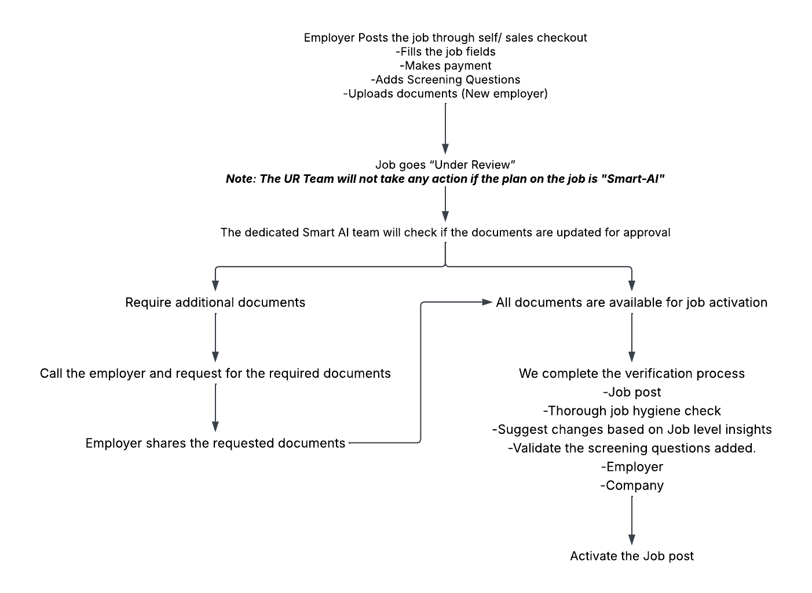

## What is a Smart AI job?

Now hiring with Apna is more efficient, thanks to the power of AI. Employers can post a job with Apna and complete the screening process through AI.

## How does it work? [Here is a detailed video](https://www.loom.com/share/c86cd2c2b5214f38ae521f110ddb1de1?sid=fd7d6dac-a817-418d-ad19-4b1dfc289fd8#Activity)

1. Employers will select “Smart AI Job” in the select plan page while posting the job.

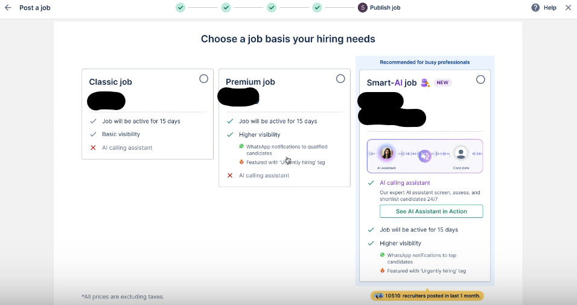

1. Recruiters can set up an AI assistant based on their preferred language (Hindi/ English).

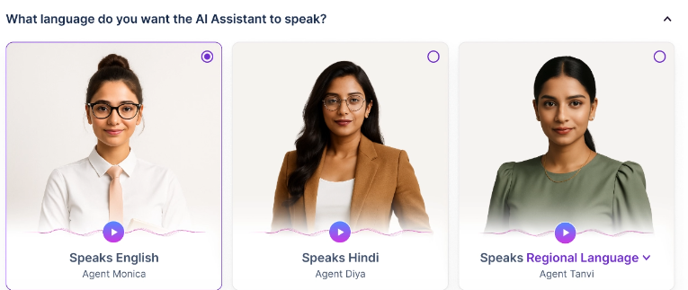

1. Adding the most relevant screening questions.
   1. Employers **can add a minimum of 5 & up to 8** screening questions.
   2. Questions can be marked as “**Compulsory**” or Optional.
   3. AI will give more importance to the questions marked as “Compulsory”.
   4. The employer also has an option to “Edit” and “Delete” a question.

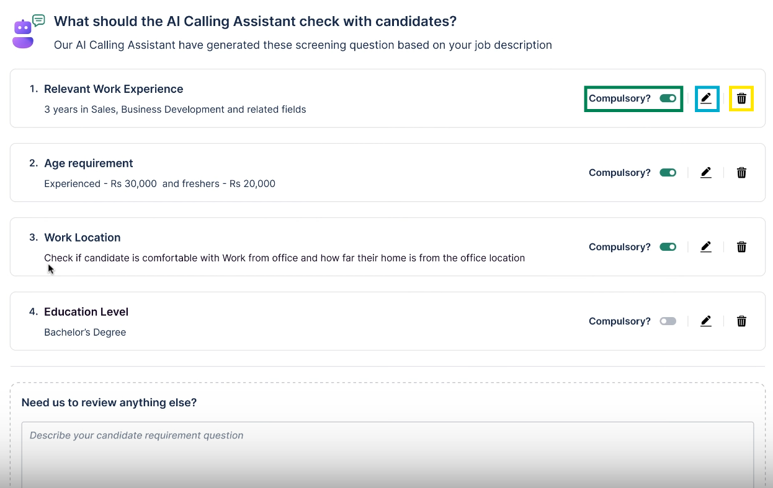

* 1. The employer can add more questions by simply describing them using the “Need us to review anything else?” section and clicking on “Generate Questions”, and the magic happens.

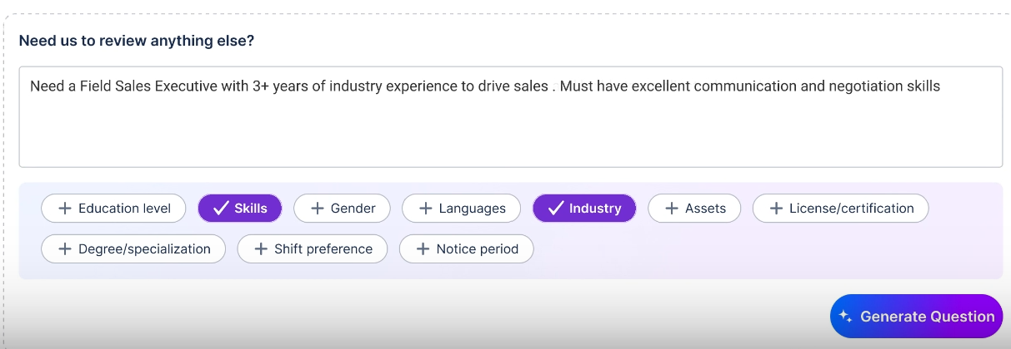

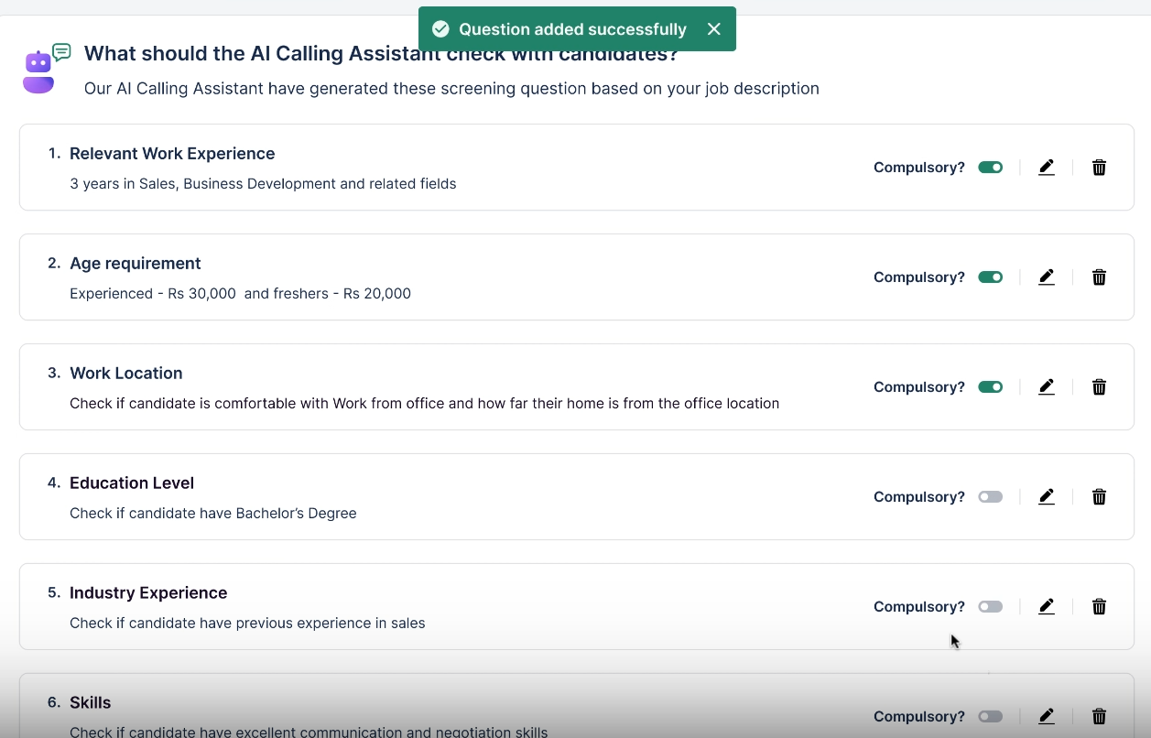

1. The job post goes **under review**, and once validated, the post goes “Active”.

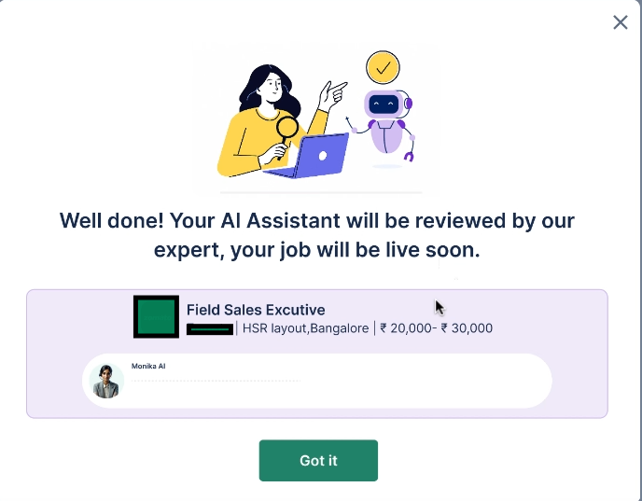

1. Once the job is “Active”, it will be visible for the candidates to apply and complete the screening process.
   1. The candidate applies for the job post by clicking on “Apply for Job”.

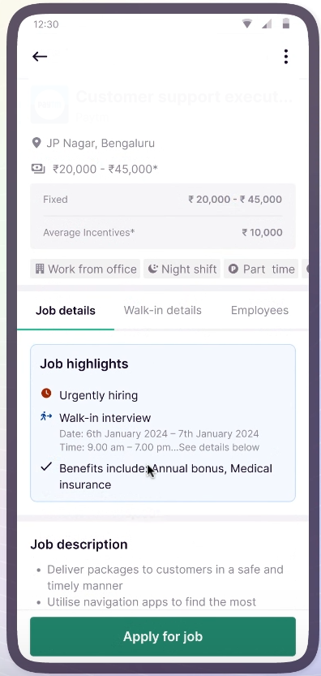

* 1. Can start the AI screening by clicking on the “**Start 2-min call**” option.

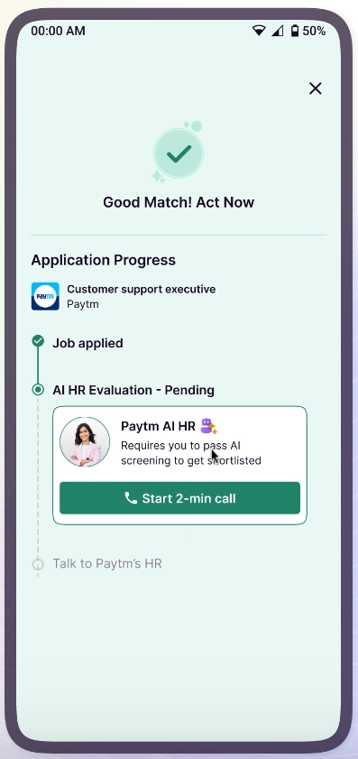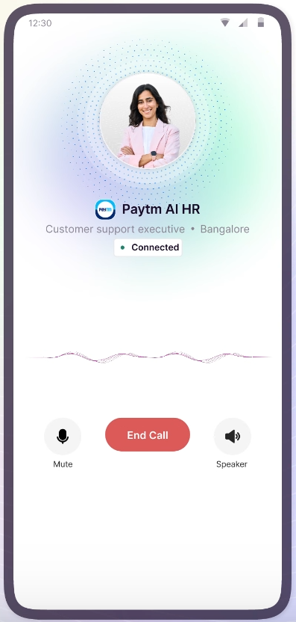

* 1. Candidates are reminded to complete the AI screening and get a total of 4 attempts to complete in 2 days.
  2. Once the candidate completes the AI screening, they can track their application.
     1. AI HR Evaluation In Progress: The application will be reviewed by AI and the results will be shared in 10-15 mins.

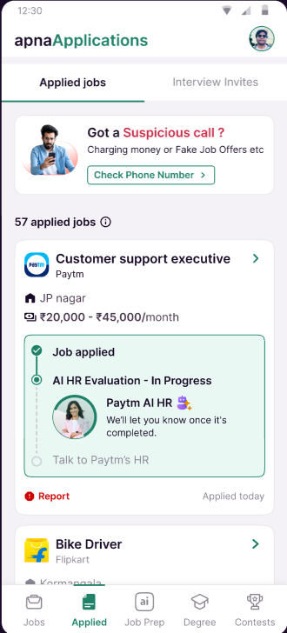

* + 1. Shortlisted by AI HR- The AI screening is complete and the candidate is shortlisted. Candidate gets an option to “Call HR”.

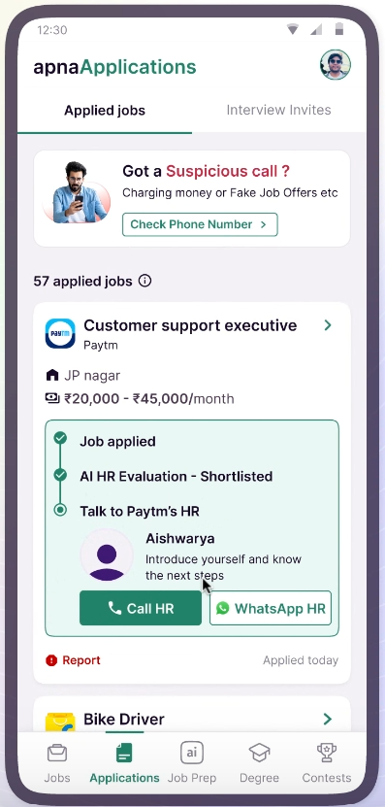

* + 1. Not Shortlisted/ Rejected: Candidate gets the reason for rejection.

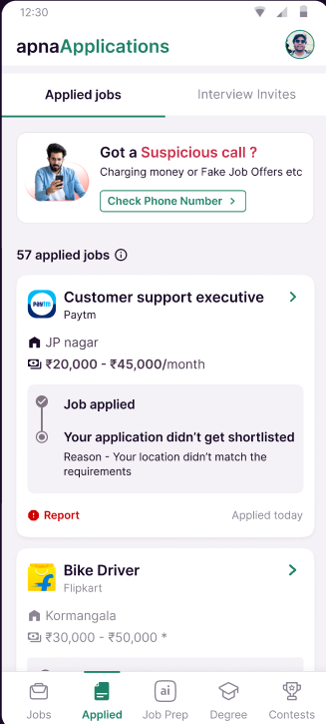

1. Employers get the results visible on their dashboard.
   1. For all completed applications, AI will share the results with the employers.
      1. Screening Pass- The candidates who cleared the AI screening.

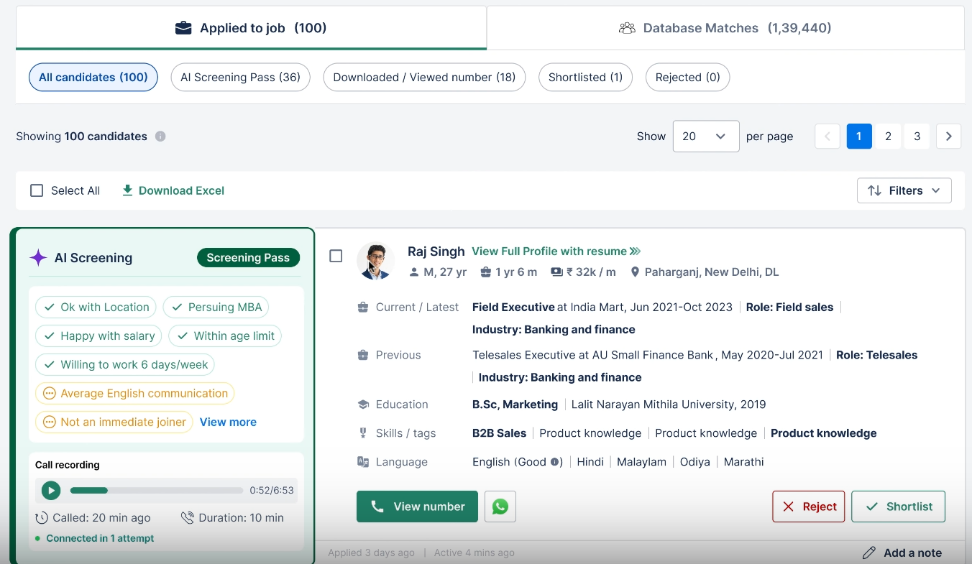

* + 1. Screening In Progress- The candidates whose screening is in progress.

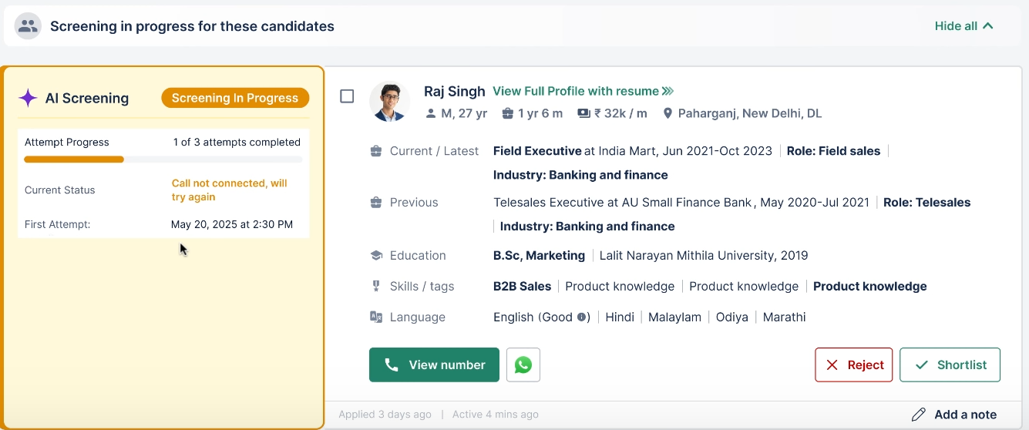

* + 1. Not Fit- Candidates marked not interested or not fit by AI.

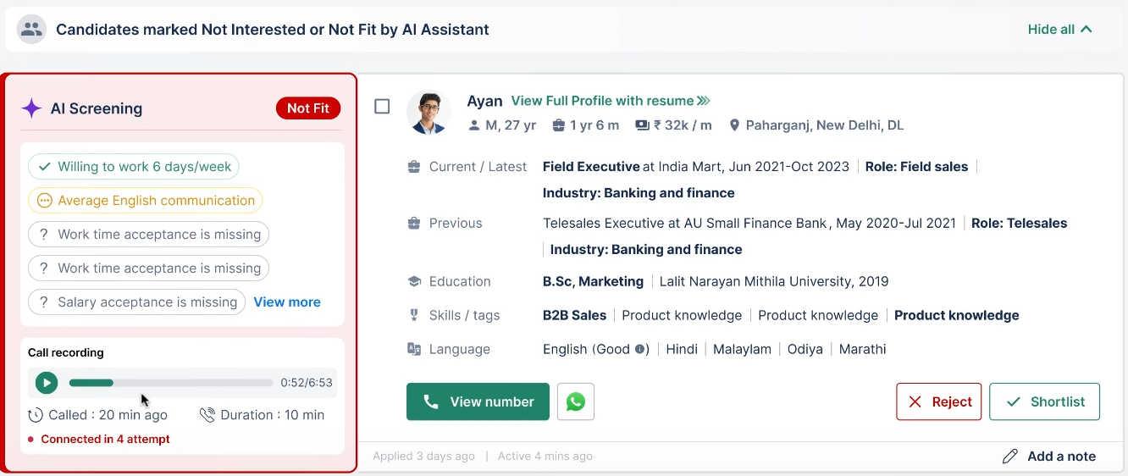

* 1. The employer gets the option to listen to the listen the recording.
  2. The employer can choose to “Shortlist” or “Reject” the applied candidates.

## What are the steps included to make the job post live?

The steps to make a Smart AI job are slightly different from the current process.

### New Employer Onboarding Process:

| **Current Onboarding Process- New** | **Smart AI Job Process- New** |
| --- | --- |
| The employer fills the job fields | The employer fills the job fields |
| Selects the plan  *Express checkout- Makes the payment* | Selects the plan  *Express checkout- Makes the payment* |
| Completes the verification | Adds screening questions |
| The job is post goes under review | Completes the verification |
| We complete the verification process   * Employer * Company * Job post * Basic hygiene check of the job post | The job is post goes under review |
| Activate the job post | **Dedicated Smart AI Team will complete the verification process**   * **Job post** * **Thorough job hygiene check** * **Suggest changes based on Job level insights** * **Validate the screening questions added.** * **Employer** * **Company** |
|  | Activate the job post |

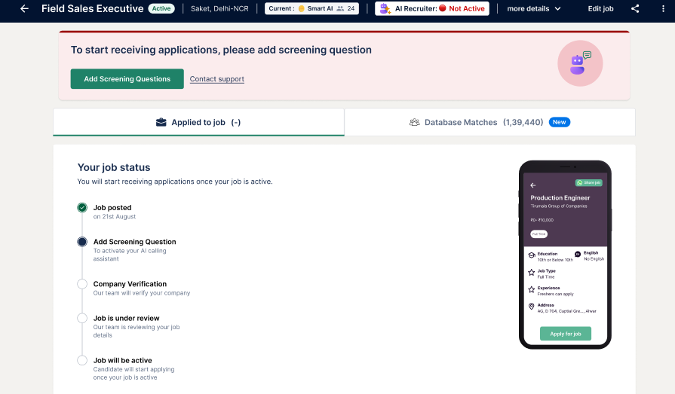

### Existing Employer Verification Process: The Smart AI jobs will not be auto-activated.

| **Current Onboarding Process- Existing** | **Smart AI Job process- Existing** |
| --- | --- |
| The employer fills the job fields | The employer fills the job fields |
| Selects the plan  *Express checkout- Makes the payment* | Selects the plan  *Express checkout- Makes the payment* |
| The job is post goes under review | **Adds screening questions** |
| We complete the verification process   * Job post * Basic hygiene check of the job post | The job is post goes under review |
| * Activate the job post | **Dedicated Smart AI Team will complete the verification process**   * **Job post** * **Thorough job hygiene check** * **Suggest changes based on Job level insights** * **Validate the screening questions added.** |
|  | * Activate the job post |

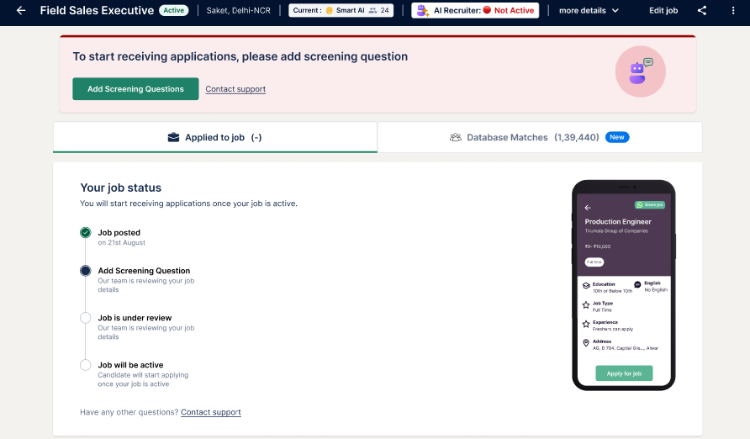

## Operational Process:

### Who takes care of the verification process for Smart AI Jobs?

A dedicated team needs to be set up to handle end-to-end verification of all jobs posted using Smart AI Job SKU.

**Picking up cases for job activation:**

* The team will be notified on the slack channel **#ai-job-post-ob-and-es** about any new job post.
* Upon receiving notification [Uttari Ghosh](mailto:uttari.ghosh@apna.co)[Mahima Sinha](mailto:mahima.sinha@apna.co) to open [mixpanel](https://mixpanel.com/s/2FYQmn) for more details of the job.
* Update the details on the [sheet](https://docs.google.com/spreadsheets/d/1-2GdY3h7lb-0xxRF53NWDNyf3Al_fldHdLJBaFTyilk/edit?gid=0#gid=0) and assign it and work towards activating it.

This team will be responsible for:

* Thorough hygiene check of the job post.
* Validating the AI screening questions.
* Employer verification of new employers.
* Activating the job post.

We will require **a tag** on the job post that will help identify if it is a Smart AI job post.

### How can we provide support to all employers who have posted a Smart AI job?

We will have a similar support function that we have for all other employers, meaning there will be Proactive support & Reactive Support.

#### Reactive Support:

The employers may contact support (Chat/ call) at 2 stages:

1. Under Review
2. Active
3. Unders Review:
   1. If the smart AI job is Under Review and the employer contacts support
   2. Pass these cases to [Bharti Gour](mailto:bharti.gour@apna.co)or [Prity Pradeep Ingle](mailto:prity.ingle@apna.co) for the job post activation.
4. Active:
   1. If the employers are complaining about LF, Relevancy or complex.
      1. W will continue to create tickets to the expert team for a solution to be provided on call.
      2. The expert team will ensure that we assist the employer.
      3. If there are any job edits done, ensure that the questions are updated and validated.
   2. If the employer complains about anything else, can provide assistance accordingly.

## Proactive Support Triggers:

| **Trigger** | **Purpose** | **Description** | **Calling Type** | **Links** |
| --- | --- | --- | --- | --- |
| **Select Plan under AI SKU- No credits** |  | When the customer selects AI SKU |  | **Sales** |
| **Purchased & not posted** | Welcome call/ assist in job posting | When customers purchase// job not posted// assist in |  | SOP  [Metabase Link](https://metabase.infra.apna.co/auth/login?redirect=%2Fquestion%2F20217-ai-sku-credits-purchase) |
| **Job posted** | Activation | All Smart AI new job posts with/ without the screening questions are to be validated and activated. | Mandatory | SOP  [Mixpanel Link- New Job Posted](https://mixpanel.com/project/1993867/view/37872/app/insights/#tzWRBF94YxW5)  Mixpanel for Edit |
| **>3 Screen Pass candidates** | Not Actioned- Reminder  Actioned- Feedback | A trigger that highlights jobs with more than 3 screen pass candidates | Optional |  |
| **<14 applied in 2 days** | Must be solved | A trigger that highlights less than 14 candidates applied for the job post. | Mandatory |  |
| **<3 Screen Pass in 2 days** | Must be solved | A trigger that highlights job posts with less than 3 candidates who have passed in 2 days. | Mandatory |  |
| **>2 Rejected of screen pass** | Must be solved | A trigger that highlights any job where the employer has rejected more than 2 of screen pass candidates | Mandatory |  |
| **>6 not actioned leads** | Reminder to action | A trigger highlighting all jobs where the employer has not taken action on the screen pass ca ndidates | Optional |  |
| **>10 screen pass candidates** | Feedback call | A trigger that highlights jobs with more than 10 candidates passed the screening. | Optional |  |
| **Day 7 - Pulse check** | Feedback call | A trigger that identifies jobs that have been active for 7 days. If the customer says there are no issues, Skip Expiry calling | Optional |  |
| **Day 15- Expiry** | Feedback call | A trigger that identifies jobs that have expired. To call only when:   1. We failed to connect with the employer during our Day 7 - Pulse check 2. If the employer mentioned that he faced issue on day 7 | Mandatory |  |

**Calling Type Definition:**

* We are supposed to call on all the set triggers.
* In case of multiple triggers, solve for all the triggers in 1 call.
* If we call the employer in a given day on any of the above mentioned triggers, and the very next day we get an optional trigger, we can skip calling to a buffer of 1 day.
* Call can be placed for such triggers the next day.

**How to do a “Thorough job hygiene check”?**

A thorough job hygiene check simply means that we understand the requirements of the employer and ensure the details on the job post are aligned with it.

**Here is how we can understand the requirements.**

1. Go through the job fields filled by the employer
   1. Job title
   2. Department & Sub-Department
   3. Skills
   4. Location
   5. Industry
   6. Gender
   7. And all the other fields.
2. Read the Job description if available.

If you do not get enough clarity on the requirements, connect with the recruiter to understand it better and suggest edits accordingly, ensuring the details on the job post are accurate.

**How to validate the screening questions?**

Mirror Log in to the employer's dashboard to validate the screening questions added.

* While you do the thorough job hygiene check, you would know what the employer's requirement is.
* Check if the screening questions are added by the employer. Use that information to further validate/ suggest to ensure all the screening questions match the requirements.
  + If not added: Work with the employer to add the most suitable screening questions.
  + If added: Evaluate and suggest changes to the screening questions if necessary.
* Refrain from adding questions that include religion, sexual, charges/ advance payments that are not mentioned on the job post.
* Seek confirmation on what questions to mark as “Compulsory”.

### What is the process to verify the employer and the company?

[**Integrated SOP - NDW**](https://docs.google.com/document/d/1Vh4AOZrxZmDbqdeCkxyY42dDVj1akj25hNlKFxZBvKY/edit?tab=t.0#heading=h.k8rsu5mc3s9k)

[**DW Verification Process**](https://docs.google.com/document/d/1jwJHMIHn7ztts51EXdrf9XKzPggPhdQEJYGBS_uD6To/edit?tab=t.0#heading=h.udtng68hbd1c)

## **Purchased & Not Posted:**

The system identifies all employers who purchased Smart AI credits and have not utilized those credits by posting a job.

If the employer has not utilized the credits after purchasing in XX hours. We will call the employer.

**We may come across 3 different employers:**

1. New to Apna + New to Smart AI (First-time user onboarding)
2. Existing Apna user + New to Smart AI (Light onboarding, product education only)
3. Reusing Smart AI user (Light onboarding; focus on engagement + support)

Steps to handle these are slightly different from one another. Here are more details.

1. **New to Apna + New to Smart AI (First-time user onboarding)**
2. **First time using smart AI and an existing employer.**
   1. Call the employer to welcome him/her to Apna family and congratulate them on getting started with Smart AI hiring.

***Script:*** *“Hi [Employer Name], this is [Your Name] from Apna. First off, welcome to the Apna family and congratulations on getting started with Smart AI hiring! We’re excited to help you find great talent quickly and efficiently.”*

* 1. Set the context of the call: To educate on how to set up and use the product.

***Script:*** *“I’d like to quickly walk you through how to set up and use Smart AI hiring so you can start attracting the best talent without wasting time.”*

* 1. Explain what to expect from Smart AI hiring

***Script:*** *“Smart AI Hiring is your shortcut to faster, smarter hiring! It’s designed to save you time and effort in your recruitment process.*

*It screens applicants for you, so you only speak to the best-fit candidates, not everyone who applies.*

*The magic lies in your job post and screening questions; the clearer they are, the sharper your results!”*

* 1. Briefly educate on how to post a Smart AI job post & the onboarding process.

***Script:*** *Here’s how you can post your first job using Smart AI and get started quickly:*

* + 1. Entering the job details and description as per the hiring requirements.

***Script:*** *First, log in to your employer account and start a new job post. Enter the job title, description, location, salary, and any other important details so candidates know exactly what you’re hiring for.*

* + 1. Selecting “AI” plan from the select plan field.

***Script:*** *In the plan selection step, make sure you choose the ‘AI’ plan — this enables automatic screening.*

* + 1. Setting up AI screening questions.

***Script:*** *Don’t worry about writing questions yourself. Smart AI will suggest screening questions based on your job details. You can review, edit, or approve them before posting.*

* + 1. **New to Apna:** Completing KYC and company verification for employer account verification.

***Script:*** *Since you’re new, you’ll need to complete KYC and company verification. This is a one-time step to confirm your company’s authenticity* Job post verification, and activation.

* + 1. **New to Smart AI:** Job post verification and activation.

***Script:*** *After submitting, our team will verify and activate your post.*

* 1. Check if the employer needs assistance with the job posting.

***Script:*** *Do you need help setting up your first job post right now? I’d be happy to guide you step by step or even help create the post on this call.*

* + 1. If requires assistance to understand job requirements and set up a job post on call with the employer.

***Script:*** *Great! could you please share the details of your hiring requirement, like job title, location, salary range, and qualifications? Let’s get this set up together.*

* + 1. If does not require assistance, move to the next step.

***Script:*** *No problem, let’s move on to a few quick best practices to help you get the best results.*

* 1. Share best practices with the employer.

***Script:*** *Here are some important tips for successful hiring with Smart AI:*

* + 1. Ensuring the job post and the AI screening questions are well aligned with the hiring requirements.

***Script:*** *Make sure your job post and screening questions align perfectly with what you’re looking for.*

* + 1. Adding screening questions relevant to the requirements and refraining from adding questions that are sexual or religious.

***Script:*** *Avoid adding any questions that could be seen as sensitive, sexual, or religious, these may lead to rejection of your post.*

* + 1. Regularly review the screen-passed candidates and contact them within 24 hours.

***Script:*** *Once your job is live, check your dashboard daily and reach out to screened candidates within 24 hours to keep them engaged. We’ve seen 50% higher conversion when employers call within 24 hours.*

* 1. Closing:

***Script:*** *Thanks so much for your time, [Employer Name]. I’m excited to see you make the most of Smart AI hiring!*

*If you need help anytime, you can reply to our support team directly. Thank you for trusting Apna!*

1. **Have used Apna and Smart AI product.**
   1. Call the employer to thank for using the Smart AI hiring once again.

***Script:*** *Hi [Employer Name], this is [Your Name] from Apna. I wanted to personally thank you for choosing Smart AI hiring again, we really appreciate your continued trust!*

* 1. Set the context of the call: Purchased credits yet not posted any job.

***Script:*** *I noticed you’ve purchased credits but haven’t posted a job yet. I wanted to check in to see how I can assist you in getting your job live quickly.*

* 1. Check for hiring requirements and understand if they require any support in posting the job.

***Script:*** *Do you have any current hiring requirements you’d like to start working on? I’d be happy to help you set up your job post or answer any questions.*

* + 1. If they have a requirement

***Script:*** *Great! Could you please share the job title, location, and key details so I can guide you?*

* + 1. If they do not have a requirement

***Script:*** *No worries. I’ll share a few best practices to help you when you’re ready.*

* 1. Share best practices with the employer.

***Script:*** *Here are some important tips for successful hiring with Smart AI:*

* + 1. Ensuring the job post and the AI screening questions are well aligned with the hiring requirements.

***Script:*** *Make sure your job post and screening questions align perfectly with what you’re looking for.*

* + 1. Adding screening questions relevant to the requirements and refraining from adding questions that are sexual or religious.

***Script:*** *Avoid adding any questions that could be seen as sensitive, sexual, or religious, these may lead to rejection of your post.*

* + 1. Regularly review the screen-passed candidates and contact them within 24 hours.

***Script:*** *Once your job is live, check your dashboard daily and reach out to screened candidates within 24 hours to keep them engaged. We’ve seen 50% higher conversion when employers call within 24 hours.*

* 1. Closing:

***Script:*** *Thanks so much for your time, [Employer Name]. I’m excited to see you make the most of Smart AI hiring! Thank you for trusting Apna!*

## **Job Activation overall flow of the conversation:**

### Pre-call Checks:

**Do a job hygiene check: this will help understand the requirement and give confidence to negotiate.**

* **Job description**
  + If the job description clearly states the requirements, roles, and responsibilities.
  + Check for sentence formation and spelling errors, as it may reduce interest in the applicants.
* **Job Fields**
  + Check if the job fields like: Job title, education, experience, location, gender, skills, etc, are aligned with the employer’s requirement.
* **Open job level insights**
  + Understand the job positioning using competition data
  + Check recommendations in the Action Centre.
* **Perform a Database search**
  + Mirror Login to the employer’s Dashboard.
  + Perform a database search based on the requirements available to check for the available candidate pool.
* **Check the screening questions added by the Employer.**
* **Add checks related to onboarding/ verification:** 
  + **Documents are perfect:** No blocker to complete KYC and company verification.
  + **Additional/ all docs needed:** Call and request the employer to share the documents for the job activation.

### **Process to be followed on call: All documents are available**

1. **Call opening and introduction:**

***Script:*** *Hi <Customer>, I am <Name>, your recruitment expert from Apna.*

1. **Purpose of the call:**

***Script:*** *Calling you to help set up your Smart AI Job you’ve posted with us, and make your job post active for the candidates to apply.*

1. **Communicate your understanding of the hiring requirements:**

***Script:*** *I see that you have posted a job for <title>, and from the details available, I have understood that you are looking for someone with (mention skills, experience, education, and other fields that are added on the job post).*

1. **Seek Clarity:**

***Script:*** *To ensure I fully understand your requirements, could you please clarify a few details? (Insert specific questions here).*

1. **Share competition data available on the job level insights dashboard & the database pool available with the current criteria:**

***Script:*** *Currently, there are X similar job posts in your region. Based on your current criteria, we have Y active candidates in our database from the past month*

1. **Share edit recommendations from the Action centre (job level insights dashboard):**

***Script:*** *Let me share a few insights top-performing employers use to boost candidate responses. Would you be open to reviewing a few quick adjustments together?*

1. Update the Database search based on the requirements discussed with the employer on the call. Use this data to negotiate edits recommended on the "Action center”.

***Script Example:***

*Right now, your job requires candidates to be <Criteria>. Based on our data, X% of top-performing jobs in your market actually hire candidates with just <updated criteria>.*

*Also, we’re seeing <Update DB Pool> matching candidates for <Updated criteria>, compared to only <DB Pool> for <Current criteria>, which is an increase in potential reach.*

*Relaxing this filter could help you tap into a wider pool of job-ready candidates and fill your position faster.*

* 1. **Employer denies to edit:**

***Script:*** *I understand you’re looking for highly specific candidates. While the quality of leads won’t be compromised with your current criteria, please note that the number of responses may be lower compared to similar jobs in your region.*

* 1. **Employer agrees to edit:**

***Script:*** *We have significantly increased our candidate pool by making edits to the job post, this gives us more confidence of the hiring to be fulfilled.*

1. **Check if the screening questions are added**
   1. **If the screening questions are already added, we need to ensure that they are aligned with the requirement:**

***Script:*** *Let’s review the AI screening questions to ensure they’re aligned with your job post. This helps ensure top-quality candidates are marked as ‘screen pass,’ and others are filtered out effectively.*

* 1. **If the screening questions are not added, work with the employer to add the most suitable screening questions:**

***Script:*** *I noticed screening questions haven’t been added yet. Let’s add the most relevant ones now to ensure your job post attracts and filters for the best candidates automatically.*

* 1. **If the question requires changes:**

***Script:*** *Let me share a few proven suggestions top employers use to improve screening accuracy and results*

* + 1. **Agrees to change:**

***Script:*** *Thank you! I’ve updated the questions. These changes should help us attract better-matched candidates.*

* + 1. **Disagrees to change**:

***Script:*** *No problem at all. We’ll still aim for quality candidates with the current questions, though the number of leads may be lower based on past trends.*

1. **Share best practices:**

***Script:*** *Before we wrap up, I’d love to quickly share some best practices that our most successful employers follow. These small steps often lead to a higher response rate and better candidate quality. Would that be okay?*

* 1. **Add Company logo**

***Script:*** *Adding your company logo to the job post builds trust and helps candidates recognize your brand easily. This simple step can improve engagement significantly.*

* 1. **Connecting with the candidates within 24 hours.**

***Script:*** *We’ve seen that reaching out to candidates within 24 hours of their application improves response rates by 50%. Quick follow-ups make candidates feel valued and reduce drop-offs. I’d recommend setting a reminder or assigning a recruiter to do this regularly.*

* 1. **Follow-up using WhatsApp Fast Recruit with a disclaimer.**

**Script:** *I recommend using our free tool, WhatsApp Fast Recruit, which helps you quickly connect with multiple candidates through bulk messaging. It’s a great way to follow up or share interview details efficiently.*

*Please use this feature with care. Sending bulk messages to many candidates at once may increase the risk of your WhatsApp account being temporarily restricted. We suggest using it primarily for candidates you’ve already attempted to call or to share important updates like interview schedules.*

* 1. **Suggest reviewing using the employer dashboard.**

***Script:*** *To stay updated and manage applications easily, I suggest regularly reviewing your Employer Dashboard. It gives you complete visibility into how your job is performing, lets you filter candidates, and helps track next steps.*

* 1. **Suggest using the Database option:**

***Script:*** *One more powerful feature I recommend is our candidate database search. You can proactively reach out to candidates who match your criteria instead of waiting for applications.*

* 1. **Support option:**

**Script:** *If you have any questions or need help at any point, our support team is available every day from 9 AM to 7 PM.*

1. **Congratulate and inform that the post is active.**

***Script:*** *Great! Your job post is now active and visible to thousands of job seekers. Congratulations! Candidates can start applying right away.*

*You’re all set for a successful hiring journey! If you need any help or want to explore more tools, feel free to reach out. Wishing you the best with your hiring — we’re here to support you at every step.*

### **>3 Screen Pass candidates / >10 screen pass candidates**

### **>6 not actioned leads**

The purpose of calling the employer is to do a pulse check on how the hiring is going.

1. **Call the employer**

*Script: “Hi <Employer Name>, this is <Your Name>, your recruitment expert from Apna. I’m just checking in to see how things are progressing with the job post for <Job Title>. You’ve received a few leads, so I wanted to understand how the hiring is going and offer any help if needed.*

1. **The employer has not acted on the leads:**
   1. **Suggest employer to action on the profiles within 24 hours**

***Script:*** *I also observed that the candidates haven’t been contacted yet from your end. I wanted to quickly share why reaching out within 24 hours makes a big difference.*

***Script:*** *We’ve seen that when employers contact candidates within 24 hours, the chances of getting them on a call go up by 2x.*

*Candidates are usually applying to multiple jobs, so connecting early improves your chances of hiring faster.*

*Many candidates even confirm interviews on the first call, especially when they hear from the employer quickly.*

1. **The employer has acted on the leads, feedback from the employer**
   1. **The employer is happy with the leads:**

***Script:*** *That’s great to hear! I’m really glad the leads have been helpful for your hiring. We always love hearing success stories from our partners.*

* 1. **The employer is unhappy:**
     1. Unhappy because the candidates are not coming for the interview
     2. Unhappy because the candidates say they are not interested.
     3. Unhappy because of the low leads received on the post
     4. Unhappy because of the quality of leads and says that the screen passed candidates are not suitable
     5. Demanding for a return due to any of the above reasons
  2. **Share best practices**
     1. Add Logo

***Script:*** *Adding your logo builds trust and increases engagement. Candidates are more likely to respond when they recognize your brand*

* + 1. Contact within 24 hours

***Script:*** *Reaching out within 24 hours can boost candidate response rates by up to 50%. Quick follow-ups reduce drop-offs.*

* + 1. Use WhatsApp Fast Recruit

***Script:*** *Use our bulk messaging tool to follow up or share interview details. Just avoid overuse to prevent WhatsApp restrictions.*

* + 1. Check Your Employer Dashboard

***Script:*** *Track applications, filter candidates, and monitor job performance easily through your dashboard.*

* 1. Share support options and resolve the call.

***Script:*** *If you have any questions or need help at any point, our support team is available every day from 9 AM to 7 PM.*

* 1. Closing:

***Script:*** *Thanks so much for your time, [Employer Name]. I’m excited to see you make the most of Smart AI hiring! Thank you for trusting Apna!*

## **<14 applied in 2 days**

The purpose of the calling is to understand the requirement, relax job criterias for better fulfillment

**Pre-call Checks:**

**Do a job hygiene check: this will help understand the requirement and give confidence to negotiate.**

* **Job description**
  + If the job description clearly states the requirements, roles, and responsibilities.
  + Check for sentence formation and spelling errors, as it may reduce interest in the applicants.
* **Job Fields**
  + Check if the job fields like: Job title, education, experience, location, gender, skills, etc, are aligned with the employer’s requirement.
* **Screening Questions:** 
  + Check if the screening questions added are aligned with the hiring requirements.
* **Open job level insights**
  + Understand the job positioning using competition data
  + Check recommendations in the Action Centre.
* **Perform a Database search**
  + Mirror Login to the employer’s Dashboard.
  + Perform a database search based on the requirements available to check for the available candidate pool.

### Call the customer:

1. **Call opening:**

***Script:*** *Hi <Customer>, I am <Name>, your recruitment expert from Apna. I’m calling regarding the job post for <Job Title> that you posted.*

1. **Communicate your understanding of the hiring requirements:**

***Script:*** *I see that you have posted a job for <title>, and from the details available, I have understood that you are looking for someone with (mention skills, experience, education, and other fields that are added on the job post).*

1. **Seek Clarity:**

***Script:*** *To ensure I fully understand your requirements, could you please clarify a few details? (Insert specific questions here).*

1. Open Job Level Insights on the employer dashboard
2. Using the “Competition data” & “Database Results”, suggest edits recommended under “Action Centre” for better response.
   1. Share how many similar postings are there in the market.

***Script:*** *Currently, there are X similar job posts in your region. Based on your current criteria*

* 1. Share the position of the post in terms of salary, incentives & perks using the data on "Competition data" with the current fields.

***Script:*** *Your post ranks in the X position compared to similar jobs in your area based on salary, incentives and perks. This means candidates may be seeing more attractive offers elsewhere, which could affect your response rate Slight improvements here can boost visibility and attract better candidates.*

* 1. Educate the employer on how editing the job will increase the job pool by editing filters on the database search.

***Script:*** *Let me share a few insights top-performing employers use to boost candidate responses. Would you be open to reviewing a few quick adjustments together?*

* 1. Update the Database search based on the requirements discussed with the employer on the call. Use this data to negotiate edits recommended on the "Action center”.

***Script Example:***

*Right now, your job requires candidates to be <Criteria>. Based on our data, X% of top-performing jobs in your market actually hire candidates with just <updated criteria>.*

*Also, we’re seeing <Update DB Pool> matching candidates for <Updated criteria>, compared to only <DB Pool> for <Current criteria> that’s increase in potential reach.*

*Relaxing this filter could help you tap into a wider pool of job-ready candidates and fill your position faster.*

* 1. If the Database search has sufficient candidates available
     1. Educate the employer about the complementary Database credits.
     2. Save the filter for the employer
     3. Inform the employer that he/she can also recruit candidates using the database search.
     4. **Suggest connecting with the candidates using a free tool, “WhatsApp Fast Recruit”, used for bulk messaging candidates:** *I recommend using our free tool, WhatsApp Fast Recruit, which helps you quickly connect with multiple candidates through bulk messaging. It’s a great way to follow up or share interview details efficiently.*
     5. **Mandatory disclaimer when suggested using WA fast recruit:** *“Please use this feature cautiously. Sending messages to a large number of people increases the risk of account blockage. Utilize it for candidates you've tried calling or to share interview details”.*
     6. Recommend contacting support for any assistance needed from our end.
  2. If the candidate pool is low in the Database:
     1. Inform the employer that, based on the requirements shared, the candidate pool is low, which is due to the criteria set by the employer.

***Script:*** *Based on the current job criteria, the candidate pool is quite limited. This is mostly due to strict filters set in the post.*

* + 1. Update the Database search based on the inputs available on the job level insights, and suggest making edits on the jobs by sharing the number of candidates available in the database.

***Script:*** *With these changes, we now see [X number] of matching candidates.*

*We recommend making these same edits on your job post to attract more applications.*

* + 1. Educate the employer about the complementary Database credits & save the filter for the employer
    2. Inform the employer that he/she can also recruit candidates using the database search.

***Script:*** *You have complimentary Database credits, so you can start reaching out to these candidates at no extra cost. I’ve saved this filter for you — you can reuse it anytime directly from your dashboard.*

* + 1. Suggest connecting with the candidates using a free tool, “WhatsApp Fast Recruit”, used for bulk messaging candidates.

***Script:*** *To connect quickly, you can use our free tool WhatsApp Fast Recruit, for bulk follow-ups or to share interview details*

* + 1. Mandatory disclaimer when suggested using WA fast recruit:

***Script:*** *“Please use this feature cautiously. Sending messages to a large number of people increases the risk of account blockage. Utilize it for candidates you've tried calling or to share interview details”.*

* + 1. Educate the employer that the job post has been edited and request the employer to review applications quickly & regularly.

***Script:*** *I’ve also updated your job post with the new filters. Please review applications regularly and reach out quickly to avoid drop-offs.*

* + 1. If the employer is unhappy and is demanding a return, try to convince the employer to wait until the expiry and suggest shortlisting candidates through the Database to complete the hiring.
       1. Employer agrees- Recommend contacting support for any assistance needed from our end.
       2. Employer denies- raise a return request by filling the return form.

1. Update the AI screening questions as per the edits done on the job and keep the most relevant questions on the job post.

## **<3 Screen Pass in 2 days**

Less than 3 screen pass candidates are available on the job post in 2 days, trigger gets generated and we need to call the employer on the 3rd day.

1. Do precall checks to understand if the job is low fulfilled
2. If low fulfilled in 2 days- solve for low fulfilment.
3. If the job received >14 leads:
   1. Check if the job needs to be relaxed using the job level insights and suggest changes.
   2. Review “Reject” candidates with the employer to check if suitable candidates were marked “Reject”.
   3. Recommend updating the screening questions based on the observations and edits made to the job post.
   4. Share details on the candidates in progress
   5. Educate and request the employer to connect with the candidates to schedule interviews.
   6. Suggest using database search and utilizing complementary Database credits before expiry.
   7. WhatsApp fast recruit (disclaimer mandate) to connect with the screen pass candidates or for follow-ups.

## **> 2 Rejected of screen pass**

If more than 30% of the candidates are rejected from the screen pass leads, trigger highlights and we call the employer to understand and solve if there are any issues.

Do a precal check on job hygiene, check if the screening questions are accurately aligned with the requirements, & review applications to understand the reason for rejection.

1. Call the employer and share the purpose of the call:

***Script:*** *Hi <Customer>, I am <Name>, your recruitment expert from Apna. I am calling to understand how is your Smart AI job for <Title> is performing.*

1. **If the employer is happy with the leads:**
   1. Request the employer to connect with the candidates within 24 hours and schedule interviews. Explain the importance of connecting faster.

***Script:*** *Great to hear that! Just a quick reminder — reaching out to candidates within 24 hours improves your chances of conversion by up to 50%.*

* 1. Recommend any changes to the job post based on the job-level insights and update screening questions.

***Script:*** *Let’s review a few changes that our top recruiters to boost their job performance and see if any small edits could help increase reach.*

*We can also fine-tune your screening questions to better match your exact requirement*.

* 1. Suggest following up with candidates using Whatsapp fast recruit (disclaimer mandatory).

***Script:*** *You can use* ***WhatsApp Fast Recruit*** *to follow up or share interview details.*

*Please use this tool cautiously. Sending bulk messages can increase the risk of WhatsApp account restriction. It’s best used for candidates you’ve already tried calling or are scheduling interviews with.*

* 1. Inform the employer about the complementary Database credits and suggest using them before expiry.

***Script:*** *You also have complimentary Database credits, I recommend using them to proactively reach out to candidates before your post expires.*

* 1. Inform available support options and close the call.

1. **If the employer is unhappy with the leads:**
   1. Understand the requirement and check if the job post and the questions added are aligned well.

***Script:*** *Let’s take a quick look together to understand what’s not working.*

*We’ll review your job post and screening questions to ensure they align with the kind of candidates you’re looking for.*

* 1. Review candidate profiles with the employer to understand if the candidates applying to the post are relevant.

***Script:*** *Let’s check a few rejected profiles, are these candidates close to your expectations, or is there a mismatch in skills, experience, or background?*

* 1. If job post and or the questions are not aligned recommend editing the job post and the questions. Further suggest modifications based on the job level insights for better fulfillment.

***Script:*** *It looks like the current filters or screening questions may be too narrow or mismatched.*

*I’d recommend updating them based on job-level insights — this will open up your reach and improve lead quality.*

* 1. If the employer denies:
     1. Inform the employer that they will continue to see similar responses if the post/ questions are not modified.

**Script:** *Totally your call — just a heads-up that if the job post or questions remain unchanged, similar candidates will continue applying.*

* + 1. Request employer to connect with the candidates within 24 hours and schedule interviews. Explain the importance of connecting faster.

***Script:*** *Reaching out within 24 hours can boost candidate response rates by up to 50%. Quick follow-ups reduce drop-offs.*

* + 1. Suggest following up with candidates using Whatsapp fast recruit (disclaimer mandatory).

***Script:*** *Use our bulk messaging tool to follow up or share interview details. Just avoid overuse to prevent WhatsApp restrictions.*

* + 1. Inform the employer about the complimentary Database credits and suggest using them before expiry.

***Script:*** *You have complimentary Database credits, so you can start reaching out to these candidates at no extra cost. I’ve saved this filter for you — you can reuse it anytime directly from your dashboard.*

* + 1. Inform available support options and close the call.

***Script:*** *Thanks so much for your time, [Employer Name]. I’m excited to see you make the most of Smart AI hiring! Thank you for trusting Apna!*

* 1. **If the employer agrees:**
     1. Edit the job post and or the screening questions.

**Script:** *Great! I’ll go ahead and update your job post and screening questions now to better match your requirements*

* + 1. Suggest following up with candidates using Whatsapp fast recruit (disclaimer mandatory).

***Script:*** *Use our bulk messaging tool to follow up or share interview details. Just avoid overuse to prevent WhatsApp restrictions.*

* + 1. Inform the employer about the complimentary Database credits and suggest using them before expiry.

***Script:*** *You have complimentary Database credits, so you can start reaching out to these candidates at no extra cost. I’ve saved this filter for you — you can reuse it anytime directly from your dashboard.*

* + 1. Inform available support options and close the call.

***Script:*** *Thanks so much for your time, [Employer Name]. I’m excited to see you make the most of Smart AI hiring! Thank you for trusting Apna!*

### **Day 7 - Pulse Check Or Day 15- Expiry**

To collect feedback from employers on their hiring experience, assess job fulfillment, understand any roadblocks, capture improvement suggestions, and gauge their willingness to reuse and recommend the Smart AI Job product.

**Process to follow to call the employer.**

Employer on Day 7 mentions no issue- We need not call the employer on expiry.

Employer on Day 7 shares that he/she is facing an issue or Unable to connect on Day 7- we need to call after the job is expired.

**Preparation Before the Call**

* Review job details: role posted, number of leads delivered, candidate engagement, and whether screening questions were used.
* Check prior interaction notes, if any.

**Call Flow & Script:**

* **Opening & Introduction:***Hi <Customer>, I am <Name>, your recruitment expert from Apna. I’m calling regarding the job post for <Job Title> that you posted.*
* **Understand Overall Experience:** *We’d love to hear your feedback on how the hiring experience was with the Smart AI Job you posted. How was your overall experience using the Apna’s Smart AI job post?*
* **Check if Hiring Was Fulfilled:** *Were you able to successfully close the position and make the hire?*
  + **If the hiring was fulfilled:** *That’s great to hear! Congratulations! Is there anything you particularly liked or found helpful in the process?*
    - **Probe to understand if the employer faced any challenges:**

*Did you face any difficulties with the job post, screening process, lead quality, or candidate responses? Was there anything that could have made the hiring journey smoother for you?*

* + **If the hiring was not fulfilled:** *Thanks for sharing. Could you help me understand what challenges you faced? This will help us improve our services for you.*
* **Ask for Suggestions to Improve:** *“We’re continuously working to improve the product. Do you have any suggestions on what we could do better or differently?”*
* **Gauge Willingness to Reuse and Recommend:** *Based on your experience, how likely are you to post another job with us in the future?” “Would you be open to recommending Apna to other recruiters or businesses?*
* **Offer Help / Next Steps:** *Thank you for the valuable feedback! If you’re planning to post another job, I’d be happy to help you set it up with some performance tips based on your previous posting. Also, just a reminder—our support team is available every day from 9 AM to 7 PM.*
* **Closing:** *Thank you again for your time and insights. We appreciate your partnership and look forward to helping you with your next hiring need!*

## 

## **Objection handling:**

### Low screen pass leads due to the criteria

*I understand it’s frustrating to see fewer screen pass leads. In our experience, this usually happens when the screening criteria are very specific or have strict eliminations. The AI filters out candidates who don’t meet even one condition, which can significantly reduce the number of matches. If you’re open to it, I’d be happy to help you review and fine-tune the questions or filters so we can increase reach without compromising on quality.*

### Unhappy because the candidates are not coming for the interview

*I completely understand how important it is to have candidates attend interviews as expected. At Apna, we’re committed to connecting you with the most relevant job seekers through quality leads. Since we operate as a professional networking platform, outcomes like interview attendance can sometimes depend on how quickly the connection is made and how well the opportunity aligns with a candidate’s preferences. To help you get the best results, I’d be glad to share a few best practices — such as reaching out promptly, sharing clear interview details, and using tools like WhatsApp Fast Recruit to gently confirm interest. We're here to support you every step of the way.*

### Unhappy because the candidates say they are not interested.

*Thank you so much for sharing that feedback — it really helps us understand how we can support you better. Sometimes, candidates may move forward with other opportunities or reconsider their plans if there’s a gap between application and follow-up. While Apna functions as a hiring platform that connects you with relevant job seekers, decisions around interest and availability can vary based on timing and fit. That said, I’d be happy to assist you in optimizing your job post and filters to attract candidates who are more closely aligned with your requirements and to encourage quicker engagement for better results.*

### Unhappy because of the low leads received on the post- Low fulfilled due to stick criteria

*I hear you, and I understand how disappointing it can be to get fewer leads. Often, when job posts have very specific filters—like limited locations, education levels, or experience ranges—it narrows the candidate pool significantly. What we can do is review those filters together and make a few small changes that can expand your reach while still bringing in relevant candidates. Would you be open to trying that?*

### Unhappy because of the quality of leads and says that the screen passed candidates are not suitable

*If the screen pass candidates aren’t matching your expectations, it’s often a sign that the screening questions or job post may need better alignment with your key requirements. I can help you rework those questions and job details so that our AI more accurately filters the right profiles for you. Even small changes here have led to much better outcomes for many of our employers.*

### Demanding a return due to any of the above reasons

If the employer is demanding for a return on credits for the above reasons:

* Ensure we acknowledge and addressed the issue accordingly.
* Have checked the active pool base and suggested edits.
* Suggested improvements based on the job level insights.

*I understand you're disappointed, and I really want to help. While we can’t issue credit returns automatically, we are committed to supporting you in completing your hiring. What I can do is work closely with you to reoptimize your job post, improve filters or screening, and even assist with our database tool so you can proactively reach more relevant candidates. Our goal is to ensure that your hiring is successful, and we’re here to do everything within our control to make that happen.*

* + **If the employer does not agree on the changes and is adamant, inform that we can issue X DB credits.**

*While credit returns aren’t something we typically offer once a job has gone live, we do value your business and want to make sure you feel supported. So, as a one-time exception, we’ll be issuing Database credits to your account. That said, I’d still love to help you make the most by helping you save database search through with you can complete your hiring. I want to make sure we set you up for success moving forward.*

* + **Employer denied for DB credits:** 
    - Seek approval from TL for Smart AI credit return and communicate accordingly.

### Employer demanding Refund:

If the employer is demanding for a refund:

* Understand reason the employer is demanding the refund for.
* Ensure we acknowledge and addressed the issue accordingly.
* Suggest edits based on the observations and database search pool.
* If the employer demands on refund without making changes.
* Educate that we do not have a refund policy however as we value relationship and offer DB credits.

*I understand you're disappointed, and I really want to help. While we can’t issue credit returns automatically, we are committed to supporting you in completing your hiring. What I can do is work closely with you to reoptimize your job post, improve filters or screening, and even assist with our database tool so you can proactively reach more relevant candidates. Our goal is to ensure that your hiring is successful, and we’re here to do everything within our control to make that happen.*

* + If the employer agrees: Add DB credits to the employers account and communicate it.
  + If employer does not agree: Seek approval from TL for Smart AI credit return and communicate accordingly.
  + *I understand that DB credits weren’t the right fit for your needs, and since we really value your relationship with us, we’re making a one-time exception to issue Smart AI credits instead. 1 AI credit have now been added to your account, and you can use them toward your next Smart AI job post. We’re committed to helping you hire successfully, so if you'd like support in optimizing your next post or using any of the platform features, I'm here to help.*
    - Employer agrees: Add Smart AI credits to the employers account and communicate it
    - Employer denies: Inform the employer this is the best we can do, and if the empoyer is adamant on getting a refund, share details with the lead to take the final call.

## Operational Process of Managing Proactive Triggers:

* All triggers will be updated on the spreadsheet on hourly basis.
* The cases wil be assigned to [Uttari Ghosh](mailto:uttari.ghosh@apna.co)[Mahima Sinha](mailto:mahima.sinha@apna.co)based on their availability.
* Call the employer and update status on the sheet respectively.

## Employer FAQs:

**How can we identify if the posted job is a Smart AI job post?**

On the employer dashboard, we will be able to see “Smart-AI” mentioned.

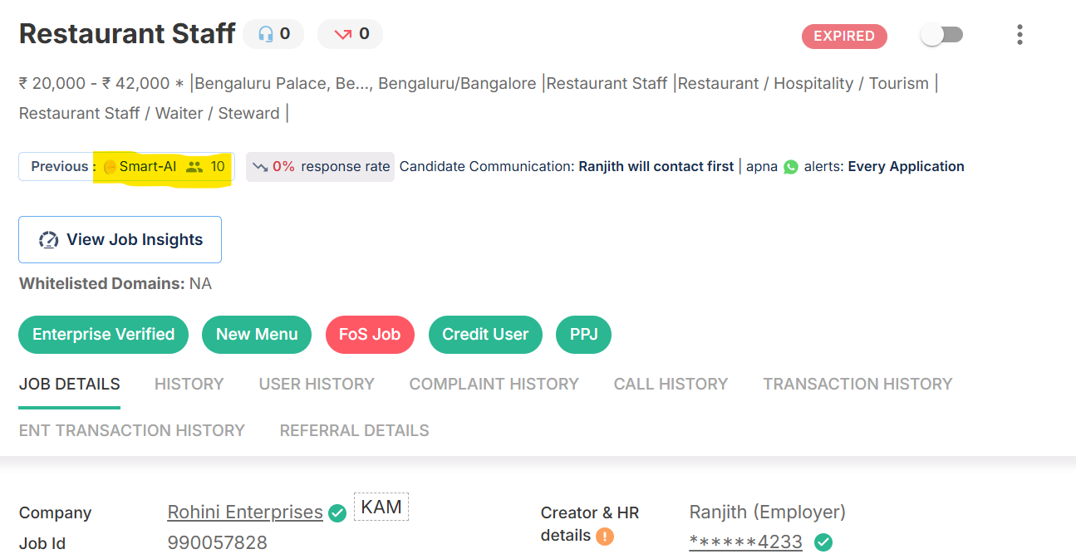

**Where can I find the option to edit the screening questions?**

* Generate a mirror login and open the job post.
* Click on the 3 dots in the top right corner of the screen

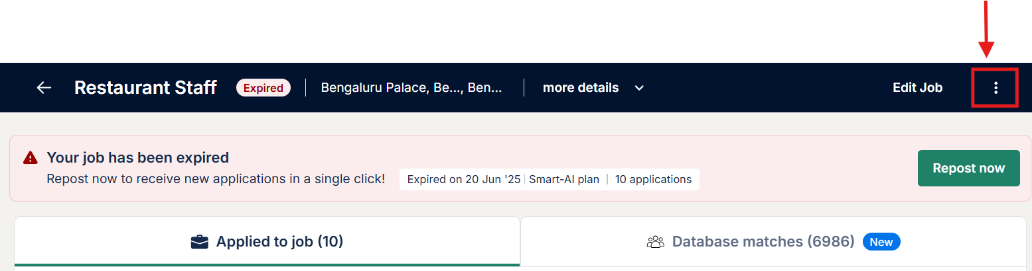

* Clicking on “AI Screening” will take you to the page where you can update the screening questions.

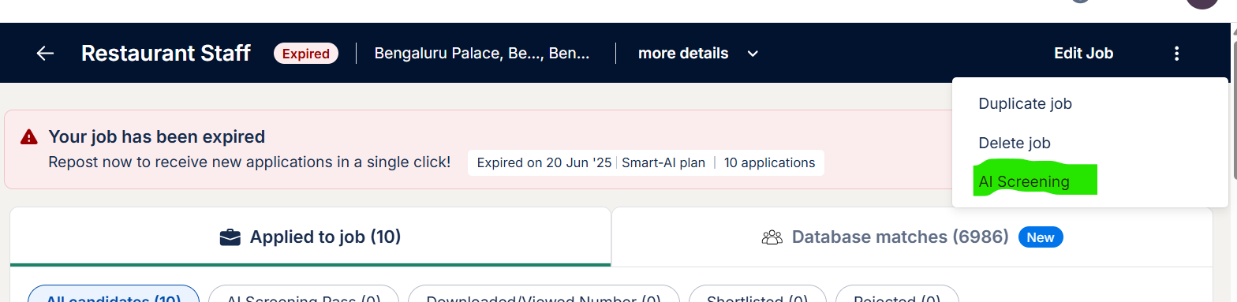

**Who will get to see the Smart AI Job?**

Currently we will show the new Smart AI Job only to SMB users who have never posted Super Premium before.

To begin with we excluded SMB users who have posted a super premium job before (x days) &

ENTs

**What needs to be done if we get a request from a ENT employer or an employer who is actively posting jobs using Super Premium?**

We will internally share details with [Ranjith J N](mailto:ranjith@apna.co) for further help.

**How can I purchase and post a Smart AI job?**

The employers can select “Smart AI job” in the select plan stage, make the payment and purchase the plan. This process in called the “express checkout”.

**What type of credits will be used to post a Smart AI job?**

Apna has introduced a new credit system named, **“Smart AI Job Credits”** which can be purchased by clicking on the “Buy Credits” option available on the employer’s dashboard.

Purchasing the “Smart AI Job credits” option will be visible to all the AI recruiters and they can purchase it by selecting the quantity and validity options available.

**Who is an AI recruiter at Apna?**

Employer who has posted 1 “Smart AI Job” becomes a AI recruiter, such employers will have an option to purchase “Smart AI Job Credits” from the employer dashboard.

**How many “Smart AI Job Credits” are need to post 1 Smart AI job?**

The employer will need to spend 1 “Smart AI Job Credits” to post a Smart AI job at Apna.

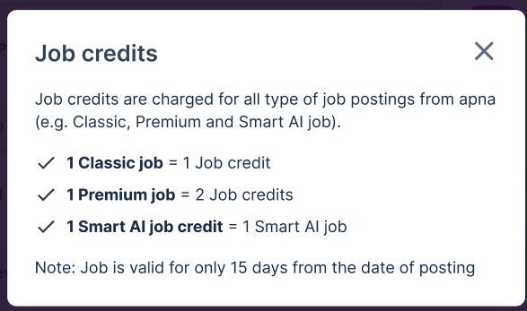

**Where can the employer check my Smart AI Job Credits balance?**

The employers can check the Smart AI Job Credits balance by clicking on the “Available credits” option.

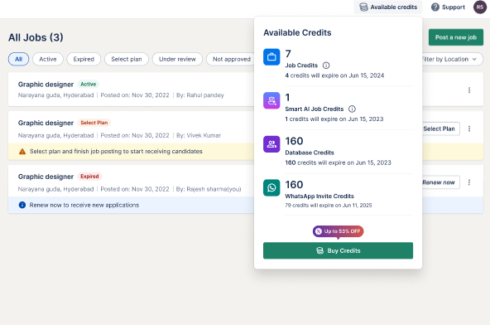

**Can the employer/ agent change the AI language?**

-Before job activation.

-After job activation.

-Job edited post activation

-Resposted jobs

-Edited and reposted jobs

Can be done

**Can the employer/ agent edit the screening questions?**

-Before job activation.

-After job activation.

-Job edited post activation

-Resposted jobs

-Edited and reposted jobs

Based on the current job only and will be applicable to the new calls only.

**The employer wants to post multiple jobs of same job title in multiple locations, can the same questions be added or has to frame questions everytime the job is posted?**

-Is repost and edit location a better option in this case?

**Can the employer download the recording or answers given by the candidate?**

No option

**What is a “Compulsory” question in AI screening?**

A “Compulsory” question is a screening question marked as must-match by the employer. If a candidate’s response does not meet the required criteria, the candidate will be automatically rejected by the AI during the screening process.

This helps ensure that only candidates who meet your non-negotiable requirements—such as location, qualification, or specific skills—are shortlisted for review.

**How many questions can be added?**

The employer can add upto 8 questions.

**Do candidate have to immediate attempt the AI interview just after applying?/ can be sceduled for later?**

The candidate can complete the AI screening within 2 days of applying, there will be 4 reminders sent to the candidates in 2 days to complete the AI screening. It is best recommended for the candidates to complete it quickly so that they move on to the next round quickly.

**Can the AI feature be enabled for Premium or Classic Plan?**

No, the employers can post a job by selecting the Smart AI Job option from the select plan screen. We have created a separate option to avoid any confusions between the job types.

**How can the employer can set up HR calling Prefernce?**

The HR calling process will remain the same, the employer can choose the preference while filling the job fields.

**Is the candidate informed before the AI interview starts?**

The candidates will complete the process from their end for such jobs and reminders will be shared for them to complete the AI screening process.

**What if a candidate refuses to take the AI interview?**

We can suggest the employer to review the candidates profile and decide whether to shortlist or reject the candidate. The employer can also connect with the candidate on call for screening, however, this will the employers decision at the end.

**Can the candidates skip the AI interview and talk to the HR directly?**

With Smart AI Job, the candidates will have to complete the AI screening. However, If the HR details are added on the job description and the candidates connect with the employers directly, it will be with the employer to decide whether to proceed with the application with or without AI screening.

**Can I share candidate interview recordings with other team members?**

No can do only throug the E dash

**What happens if a candidate has technical issues during the interview?**

The candidates interview will not be marked complete, they can complete the AI screening within 2 days from the time they applied on the job.

**Do candidates need to download an app or software?**

There is no need to download any additional software or applications, this will be enabled on the Apna app or can also be completed by using the official [apna.co](http://apna.co) website.

**Can candidates select a preferred language for the AI screening?**

Currently, the employer selects the preferred language (English or Hindi) while setting up the job post. The AI screening process is then conducted in that same language for all candidates applying to that job.

**How many attempts will the candidates get to complete the AI screening process?**

The candidates get 1 attempt to complete the AI screening process in 2 days from the applied day.

**Can we add question in regional language? In how many regional language do we have AI screening available?**

At present, AI screening questions are supported in English and Hindi. These are the two languages currently available for Smart AI screening to ensure accurate understanding and response evaluation by the system.

We’re actively working to expand support to additional regional languages based on demand and usage.

**Will an AI interview recording be attached to every profile for the employer to review the conversation that took place between the AI and the candidate?**

Yes, for all screen pass candidates there will be a recording available and the employers can listen to the recording themselves.